Supporting Information

Fig S1. Effect of greenhouses on mean diel air and soil temperatures at 10 cm depth measured using dataloggers through the 2008, 2009 and 2011 growing seasons (a), and daytime soil temperatures at 2 cm and 10 cm depth measured manually in summer 2006 (b).
Fig S2. Greenhouse treatment increase in mean diel temperature and 4 pm temperatures through the growing season.
Table S1. Linear regression parameters used for the hits: biomass calibration
Table S2. Bonferroni correction thresholds for the species-level analyses
Table S3. Dissolved organic, inorganic, and microbial soil C, N and P pools in the the warming and fertilization treatments
Table S4. Plant part- and age-differentiated biomass for all species and functional groups in the warming and fertilization treatments
Table S5. Effect of greenhouses on soil moisture
Table S6. Effects of greenhouse warming and low-level N additions on dissolved organic and inorganic C, N, and P pools
Table S7. Effects of factorial N and P additions on dissolved organic and inorganic C, N, and P pools
Table S8. Number of inflorescences and fruits for vascular plant species in the greenhouse warming and control plots

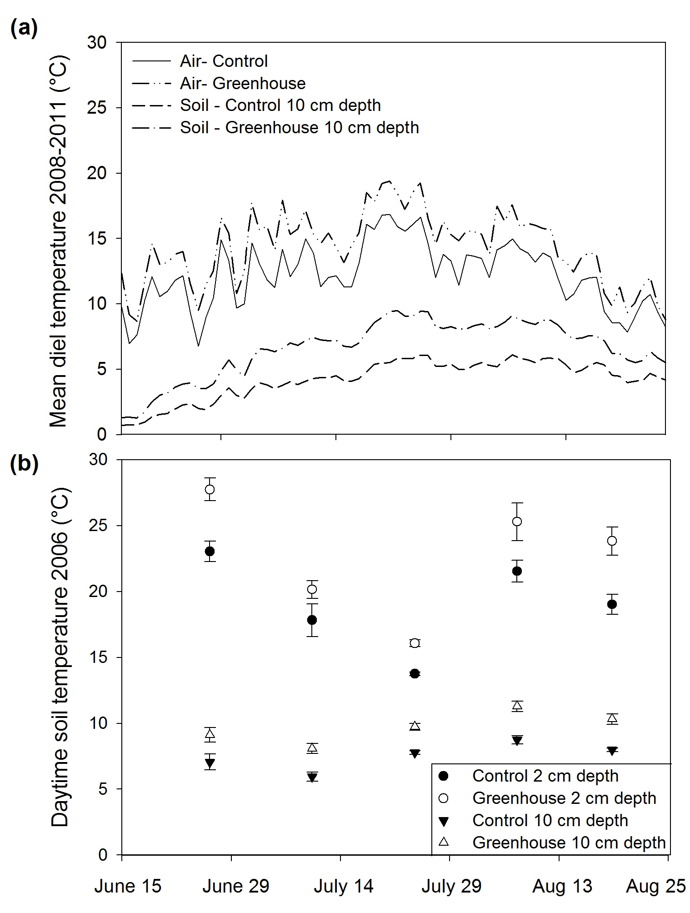
Fig S1. Effect of greenhouses on mean diel air and soil temperatures at 10 cm depth measured using dataloggers through the 2008, 2009 and 2011 growing seasons (a), and daytime soil temperatures at 2 cm and 10 cm depth measured manually in summer 2006 (b). Error bars in (b) are standard errors (n=5 plots with 12 recordings per plot per date).

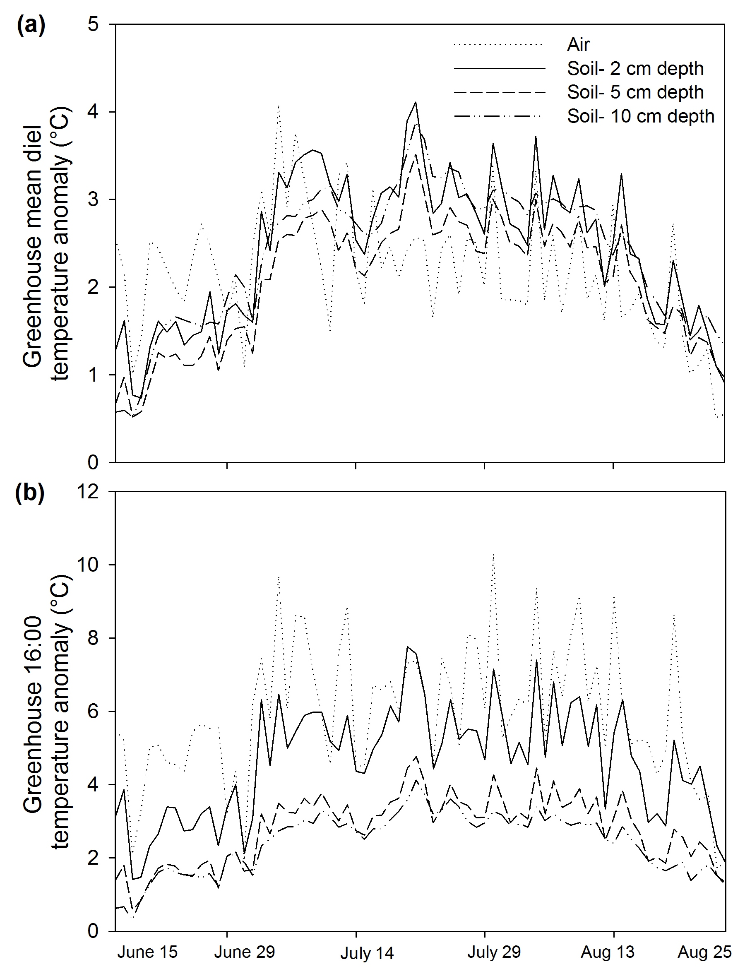
Fig S2. Greenhouse treatment increase in mean growing season air and soil diel temperatures (a), and 4 pm (close to daily peak) air and soil temperatures (b) throughout the growing seasons of 2008, 2009 and 2011 (datalogger malfunction in 2010). Data are based on 4-hourly averages of 2 probes per depth per treatment.

Table S1. Linear regression parameters used for the hits: biomass calibration. Data used in the calibration were natural log-transformed aboveground biomass and natural-log transformed number of point framing hits on aboveground biomass. Original equation: Y = kX^{n}; Taking the natural log of both sides becomes: ln Y = n ln X + ln k; Let Y’ = ln Y and X’ = ln X; Linear equation is: Y’= aX’ + b; Solved for Y is then: Y=exp(a ln X + b). The calibration for C. laevigata used the C. islandica equation due to insufficient C. laevigata hits in the 0.16 m⁻² area
 |  |  |  | Slope |  |  | Intercept
 | r² | P |  | Value | 1 SE |  | Value | 1 SE
Betula glandulosa
Leaves | 0.38 | 0.0003 |  | 0.49 | 0.13 |  | 0.95 | 0.28
Stem | 0.26 | 0.0038 |  | 0.71 | 0.22 |  | 2.34 | 0.31
Vaccinium uliginosum
Leaves | 0.71 | <0.0001 |  | 0.48 | 0.06 |  | 0.28 | 0.09
Stem | 0.27 | 0.0033 |  | 0.83 | 0.26 |  | 1.07 | 0.25
Rhododendron subarcticum
Leaves | 0.86 | <0.0001 |  | 0.74 | 0.06 |  | 0.53 | 0.20
Stem | 0.50 | <0.0001 |  | 0.82 | 0.12 |  | 2.14 | 0.36
Vaccinium vitis-idaea
Leaves | 0.90 | <0.0001 |  | 0.83 | 0.05 |  | 0.36 | 0.18
Stem | 0.38 | 0.0003 |  | 0.65 | 0.16 |  | 1.57 | 0.26
Andromeda polifolia
Leaves | 0.57 | <0.0001 |  | 0.71 | 0.12 |  | 0.52 | 0.17
Stem | 0.18 | 0.0211 |  | 0.67 | 0.27 |  | 1.02 | 0.22
Eriophorum vaginatum | 0.79 | <0.0001 |  | 0.58 | 0.06 |  | 0.90 | 0.21
Rubus chamaemorus | 0.80 | <0.0001 |  | 0.74 | 0.07 |  | 0.21 | 0.10
Mosses | 0.59 | <0.0001 |  | 0.64 | 0.10 |  | 2.49 | 0.29
Lichens
Alectoris ochroleuca | 0.59 | <0.0001 |  | 0.34 | 0.05 |  | 0.16 | 0.06
Bryocaulon divergens | 0.23 | 0.0075 |  | 0.27 | 0.09 |  | 0.58 | 0.15
Cetraria cucullata | 0.67 | <0.0001 |  | 0.78 | 0.10 |  | 0.37 | 0.39
Cetraria islandica | 0.27 | 0.0034 |  | 0.29 | 0.09 |  | 0.86 | 0.14
Cetraria nivalis | 0.08 | 0.1396 |  | 0.21 | 0.14 |  | 1.43 | 0.29
Cladina mitis | 0.39 | 0.0002 |  | 0.44 | 0.10 |  | 1.17 | 0.21
Cladina rangiferina | 0.44 | <0.0001 |  | 0.48 | 0.10 |  | 1.56 | 0.27
Cladonia gracilis | 0.22 | 0.0084 |  | 0.31 | 0.11 |  | 1.13 | 0.17
Masonhalea richardsonni | 0.80 | <0.0001 |  | 1.03 | 0.10 |  | 0.27 | 0.11
Table S2. Bonferroni correction thresholds for the species-level analyses. α = 0.05/(number of above- or below-ground tissues being compared for a given species). Aboveground and belowground plant parts were considered as two separate groups for the warming analysis so that α for any given aboveground part remained the same for the warming analyses and for the fertilization analyses
 | Warming analysis |  | Fertilization analyses
 | α |  | α
B. glandulosa
Leaves | 0.0167 |  | 0.0167
New stem | 0.0167 |  | 0.0167
Old stem | 0.0167 |  | 0.0167
Fine roots | 0.0167
Coarse roots | 0.0167
Belowground stem | 0.0167
Total aboveground | 0.05
Total belowground | 0.05
Total above- and belowground | 0.05
V. uliginosum
Leaves | 0.0167 |  | 0.0167
New stem | 0.0167 |  | 0.0167
Old stem | 0.0167 |  | 0.0167
Fine roots | 0.0250
Coarse roots | 0.0250
Total aboveground | 0.05
Total belowground | 0.05
Total above- and belowground | 0.05
R. subarcticum
New leaves | 0.0125 |  | 0.0125
New stem | 0.0125 |  | 0.0125
Old leaves | 0.0125 |  | 0.0125
Old stem | 0.0125 |  | 0.0125
Fine roots | 0.0167
Coarse roots | 0.0167
Belowground stem | 0.0167
Total aboveground | 0.05
Total belowground | 0.05
Total above- and belowground | 0.05
V. vitis-idaea
New leaves | 0.0125 |  | 0.0125
New stem | 0.0125 |  | 0.0125
Old leaves | 0.0125 |  | 0.0125
Old stem | 0.0125 |  | 0.0125
Fine roots | 0.05
Total aboveground | 0.05
Total above- and belowground | 0.05
A. polifolia
New leaves | 0.0125 |  | 0.0125
New stem | 0.0125 |  | 0.0125
Old leaves | 0.0125 |  | 0.0125
Old stem | 0.0125 |  | 0.0125
Fine roots | 0.05
Total aboveground | 0.05
Total above- and belowground | 0.05
E. vaginatum
Blades | 0.0250 |  | 0.0250
Sheaths | 0.0250 |  | 0.0250
Fine roots | 0.05
Total aboveground | 0.05
Total above- and belowground | 0.05
R. chamaemorus
Shoots | 0.05 |  | 0.05
Rhizomes | 0.05
Total above- and belowground | 0.05
Mosses
Sphagnum spp. | 0.0250 |  | 0.0250
Non-Sphagnum spp. | 0.0250 |  | 0.0250
Total mosses | 0.05 |  | 0.05
Lichen
Each individual spp. | 0.05 |  | 0.05
Total lichens | 0.05 |  | 0.05

Table S3. Dissolved organic, inorganic, and microbial soil C, N and P pools in the the warming and fertilization treatments. Mean values are presented, with standard error in parentheses (n=5)

 | Control |  | Greenhouse |  | Low N addition |  | High N addition |  | High P addition |  | High N+P addition
DOC (g m⁻²) | 9.74  (0.83) |  | 13.49  (1.92) |  | 14.83  (2.93) |  | 9.44  (0.64) |  | 11.05  (1.63) |  | 9.52  (0.89)
DON (mg m⁻²) | 572.82  (66.05) |  | 642.09  (95.15) |  | 1177.27 (189.50) |  | 9074.80 (2680.72) |  | 888.15 (142.54) |  | 3943.06 (1119.31)
NH₄-N (mg N m⁻²) | 16.66  (3.51) |  | 19.33  (2.26) |  | 78.56  (35.92) |  | 5299.09 (2618.58) |  | 278.26 (167.25) |  | 1646.12 (792.33)
NO₃-N (mg N m⁻²) | 0.17  (0.11) |  | 1.03  (0.61) |  | 1.80  (0.84) |  | 509.33 (174.81) |  | 12.05  (8.86) |  | 234.48 (107.92)
PO₄-P (mg P m⁻²) | 51.02  (6.22) |  | 71.27  (12.97) |  | 37.63  (12.31) |  | 68.56  (18.02) |  | 2180.56 (525.48) |  | 1290.75 (253.11)
MBC (g m⁻²) | 38.73 (2.14) |  | 41.00 (2.50) |  | 56.54 (7.28) |  | 37.35 (1.80) |  | 26.41 (3.53) |  | 28.09 (3.65)
MBN (g m⁻²) | 3.45 (0.19) |  | 3.40 (0.40) |  | 6.42 (0.93) |  | 6.01(1.06) |  | 4.00 (0.41) |  | 5.52 (0.64)
MBP (g m⁻²) | 0.49 (0.17) |  | 0.88 (0.29) |  | 0.36 (0.12) |  | 0.27 (0.09) |  | 0.74 (0.30) |  | 0.81 (0.20)
Table S4. Plant part- and age-differentiated biomass (g m⁻²) for all species and functional groups in the warming and fertilization treatments. Mean values are presented, with standard error in parentheses (n=5); “n.a.” indicates standard error not available, as all replicates had the same extrapolated biomass at 1.0 m²
 | Control |  | Greenhouse |  | Low N addition |  | High N addition |  | High P addition |  | High N+P addition
B. glandulosa
Leaves | 2.68 (0.45) |  | 6.02 (1.01) |  | 4.31 (1.25) |  | 5.09 (0.80) |  | 7.41 (1.38) |  | 8.57 (1.92)
New stem | 0.28 (0.06) |  | 0.87 (0.27) |  | 0.22 (0.08) |  | 2.79 (1.15) |  | 0.97 (0.27) |  | 4.75 (2.44)
Old stem | 11.66 (1.55) |  | 31.72 (9.28) |  | 17.83 (5.48) |  | 23.99 (4.42) |  | 28.89 (7.53) |  | 29.57 (14.69)
Fine roots | 3.22 (1.16) |  | 11.02 (3.02)
Coarse roots | 7.91 (2.02) |  | 7.98 (1.91)
Belowground stem | 34.33 (4.53) |  | 24.15 (6.41)
V. uliginosum
Leaves | 1.08 (0.37) |  | 1.32 (0.42) |  | 2.00 (0.86) |  | 0.32 (n.a.) |  | 1.69 (0.93) |  | 0.32 (n.a.)
New stem | 0.17 (0.07) |  | 0.27 (0.10) |  | 0.32 (0.13) |  | 0.14 (0.01) |  | 0.25 (0.04) |  | 0 (0)
Old stem | 3.50 (1.01) |  | 7.15 (2.95) |  | 5.68 (2.11) |  | 1.78 (0.01) |  | 2.59 (0.54) |  | 1.93 (n.a.)
Fine roots | 4.55 (1.32) |  | 9.39 (5.06)
Coarse roots | 5.00 (3.14) |  | 3.99 (2.18)
R. subarcticum
New leaves | 18.04 (0.95) |  | 28.75 (2.01) |  | 16.83 (2.76) |  | 4.49 (2.15) |  | 14.59 (3.33) |  | 5.28 (2.83)
New stem | 2.62 (0.43) |  | 5.82 (0.58) |  | 3.66 (0.83) |  | 0.59 (0.27) |  | 2.76 (0.86) |  | 3.86 (0.90)
Old leaves | 12.66 (1.24) |  | 39.30 (4.09) |  | 14.21 (2.05) |  | 2.82 (1.03) |  | 6.78 (1.43) |  | 0.67 (0.40)
Old stem | 81.37 (13.63) |  | 146.87 (16.41) |  | 71.78 (12.79) |  | 14.14 (4.00) |  | 33.51 (11.02) |  | 14.72 (8.68)
Fine roots | 26.95 (6.06) |  | 67.64 (6.43)
Coarse roots | 101.71 (17.61) |  | 245.11 (27.75)
Belowground stem | 10.36 (1.25) |  | 42.06 (4.21)
V. vitis-idaea
New leaves | 16.03 (0.71) |  | 18.77 (2.83) |  | 11.47 (2.46) |  | 1.96 (0.92) |  | 9.22 (2.33) |  | 0.43 (0.17)
New stem | 1.15 (0.17) |  | 2.16 (0.35) |  | 1.49 (0.33) |  | 0.28 (0.07) |  | 1.31 (0.50) |  | 0.58 (0.08)
Old leaves | 29.89 (2.78) |  | 33.95 (3.17) |  | 23.61 (5.63) |  | 3.78 (1.70) |  | 9.54 (2.30) |  | 1.29 (0.38)
Old stem | 12.23 (1.13) |  | 18.39 (2.58) |  | 15.45 (3.21) |  | 4.55 (0.99) |  | 9.14 (2.64) |  | 3.23 (0.08)
Fine roots | 83.84 (13.59) |  | 61.33 (7.05)
A. polifolia
New leaves | 3.33 (1.43) |  | 3.31 (0.65) |  | 4.49 (1.26) |  | 1.67 (0.93) |  | 1.71 (0.59) |  | 0.91 (0.59)
New stem | 0.20 (0.07) |  | 0.37 (0.10) |  | 0.50 (0.21) |  | 0.22 (0.11) |  | 0.14 (0.04) |  | 0.18 (0.04)
Old leaves | 4.45 (1.91) |  | 5.46 (1.02) |  | 4.72 (1.14) |  | 1.28 (0.82) |  | 0.82 (0.24) |  | 1.03 (0.66)
Old stem | 4.02 (1.31) |  | 5.25 (1.66) |  | 6.99 (1.56) |  | 3.06 (1.39) |  | 1.97 (0.29) |  | 2.21 (0.56)
Fine roots | 16.39 (6.68) |  | 18.22 (5.18)
E. vaginatum
Blades | 6.90 (1.83) |  | 13.23 (1.67) |  | 10.91 (1.86) |  | 13.67 (3.93) |  | 16.20 (5.66) |  | 51.75 (11.09)
Sheaths | 5.19 (1.52) |  | 9.51 (1.47) |  | 4.40 (1.23) |  | 4.92 (1.75) |  | 6.45 (2.61) |  | 19.48 (4.37)
Fine roots | 3.14 (0.73) |  | 6.15 (0.93)
R. chamaemorus
Shoots | 1.00 (0.40) |  | 1.11 (0.57) |  | 0.56 (0.20) |  | 0.87 (0.29) |  | 4.97 (1.84) |  | 8.33 (3.52)
Rhizomes | 9.02 (4.93) |  | 10.09 (5.22)
Mosses
Sphagnum spp. | 6.15 (2.59) |  | 32.93 (14.27) |  | 38.62 (19.88) |  | 0.16 (0.16) |  | 14.13 (11.91) |  | 0.73 (0.73)
Non-Sphagnum spp. | 66.07 (8.81) |  | 50.75 (6.60) |  | 68.99 (13.16) |  | 40.71 (9.25) |  | 68.37 (15.90) |  | 80.28 (20.45)
Lichens
Alectoris ochroleuca | 1.04 (0.24) |  | 0.42 (0.15) |  | 0.81 (0.16) |  | 0.38 (0.14) |  | 0.56 (0.24) |  | 0.30 (0.08)
Bryocaulon divergens | 2.57 (0.09) |  | 1.23 (0.19) |  | 2.43 (0.39) |  | 2.08 (0.19) |  | 1.81 (0.27) |  | 1.61 (0.39)
Cetraria cucullata | 35.95 (1.70) |  | 16.94 (2.13) |  | 29.50 (3.48) |  | 25.39 (2.12) |  | 30.63 (1.57) |  | 17.13 (4.35)
Cetraria islandica | 2.65 (0.35) |  | 2.27 (0.35) |  | 2.12 (0.23) |  | 2.36 (0.43) |  | 2.49 (0.06) |  | 1.83 (0.35)
Cetraria laevigata | 1.75 0.17) |  | 1.47 (0.11) |  | 1.86 (0.26) |  | 1.36 (n.a.) |  | 1.68 (0.13) |  | 1.47 (0.11)
Cetraria nivalis | 6.26 (0.12) |  | 3.93 (0.34) |  | 6.58 (0.29) |  | 6.04 (0.28) |  | 3.32 (0.13) |  | 5.65 (0.65)
Cladina mitis | 11.16 (1.00) |  | 3.70 (0.21) |  | 10.96 (1.10) |  | 6.74 (1.16) |  | 5.75 (1.63) |  | 5.06 (0.90)
Cladina rangiferina | 21.20 (2.74) |  | 10.93 (1.01) |  | 26.08 (1.50) |  | 17.85 (2.60) |  | 14.62 (2.89) |  | 9.16 (2.11)
Cladonia gracilis | 4.27 (0.61) |  | 2.73 (0.31) |  | 4.59 (0.78) |  | 3.64 (0.59) |  | 3.32 (0.47) |  | 2.25 (0.15)
Masonhalea richardsonni | 6.54 (2.96) |  | 1.15 (0.83) |  | 1.71 (1.40) |  | 2.29 (1.98) |  | 7.40 (3.19) |  | 3.69 (2.13)
Total lichen | 96.97 (3.88) |  | 48.16 (3.48) |  | 90.25 (6.33) |  | 72.12 (4.25) |  | 75.31 (3.87) |  | 52.04 (8.75)
Standing dead | 100.83 (25.67) |  | 163.40 (27.70) |  | 95.73 (18.32) |  | 116.45 (22.67) |  | 142.39 (35.54) |  | 297.83 (69.37)
Litter | 786.30  (77.51) |  | 600.74 (121.93) |  | 857.39 (269.78) |  | 1273.93 (103.52) |  | 1068.11 (39.81) |  | 913.04 (157.12)

Table S5. Effects of greenhouses on soil moisture. All measurements are for 0-8 cm depth, with the exception of 20 Aug Surface measurements which were 0-4 cm depth. Measurements collected at 6 tussock and 6 inter-tussock locations within each plot, at 5 dates throughout the 2006 growing season. Statistical test results from repeated measures ANOVA on 5 dates with measurements at 0-8 cm depth; no data transformation used; d.f.=degrees of freedom

 | Soil moisture (%)
 | 24 June | 10 July | 24 July | 7 Aug | 20 Aug | Surface- 20 Aug
Tussocks:
Control | 21.8 (3.6) | 29.0 (2.6) | 28.1 (2.7) | 19.9 (2.3) | 18.3 (2.8) | 13.6 (2.8)
Warming | 24.1 (3.2) | 26.7 (3.5) | 26.8 (2.9) | 19.5 (2.0) | 18.8 (2.7) | 12.8 (2.2)
Treatment effect: | d.f. = 1,8 | F<0.01 | P=0.94
Date effect: | d.f.= 4, 32 | F=8.41 | P<0.01*
Trt* Date effect: | d.f.= 4,32 | F=0.37 | P=0.83
 | Soil moisture (%)
 | 24 June | 10 July | 24 July | 7 Aug | 20 Aug | Surface- 20 Aug
Inter-tussocks:
Control | 40.4 (2.4) | 41.8 (3.2) | 43.2 (1.9) | 41.5 (5.5) | 34.1 (3.7) | 22.7 (3.6)
Warming | 41.0 (4.0) | 51.7 (4.0) | 46.7 (4.9) | 40.2 (2.1) | 36.3 (1.8) | 21.2 (1.9)
Treatment effect: | d.f. = 1,8 | F=0.65 | P=0.44
Date effect: | d.f.= 4, 32 | F=5.69 | P<0.01*
Trt* Date effect: | d.f.= 4,32 | F=1.28 | P=0.30

Table S6. Effects of greenhouse warming and low-level N additions on dissolved organic and inorganic C, N, and P pools. Results from two separate analyses; t-test of Greenhouses and Controls; and t-tests of Low-N and Controls. In all cases, degrees of freedom= 8. Bolded values indicate tests are significant (P<0.05). Symbols following P values indicate the data transformations used to achieve homogeneity of variances: no symbol, not transformed; †log-transformed; rc, reciprocal transform; W, Wilcoxon rank sum test on raw data
 |  | Warming |  |  | Low-level N addition
 |  | T | P |  | T | P
DOC | (g m⁻²) | -1.79 | 0.111 |  | -1.88 | 0.096†
DON | (mg m⁻²) | -0.60 | 0.566 |  | -3.01 | 0.017
NH₄-N | (mg N m⁻²) | -0.64 | 0.541 |  | -2.69 | 0.028^{rc}
NO₃-N | (mg N m⁻²) | W=8 | 0.473 |  | W=4.5 | 0.106
PO₄-P | (mg P m⁻²) | -1.41 | 0.197 |  | 0.97 | 0.360

Table S7. Effects of factorial N and P additions on dissolved organic and inorganic C, N, and P pools. Degrees of freedom= 1,19 in all tests. Bolded values indicate tests that are significant (P<0.05). In the Tukey results, treatments that do not share the same superscript letter(s) are significantly different (P<0.05). DOC= dissolved organic carbon; DON= dissolved organic nitrogen. Symbols following variable name indicate the data transformations used to achieve homogeneity of variances: no symbol, not transformed; †log-transformed; W, Wilcoxon rank sum test on raw data

 |  | N effect |  |  | P effect |  |  | N x P interaction |  | Post-hoc Tukey
 |  | F | P |  | F | P |  | F | P
DOC | (g m⁻²) | 0.74 | 0.402 |  | 0.42 | 0.527 |  | 0.33 | 0.573
DON | (mg m⁻²) | W=81 | 0.019 |  | W=54 | 0.796 |  | NA
NH₄-N† | (mg N m⁻²) | 69.23 | <0.001 |  | 1.11 | 0.307 |  | 15.19 | 0.001 | Control^{c}; High Nª; High P^{b}; High NPª
NO₃-N† | (mg N m⁻²) | 31.4 | <0.001 |  | 0.00 | 0.957 |  | 3.05 | 0.100 | Control^{c}; High Nª; High P^{b,c}; High NP^{a,b}
PO₄-P† | (mg P m⁻²) | 0.410 | 0.531 |  | 240.83 | <0.001 |  | 2.41 | 0.140 | Control^{b}; High N^{b}; High Pª; High NPª

Table S8. Number of inflorescences and fruits for vascular plant species in the greenhouse warming and control plots. Mean values are presented, with standard error in parentheses (n=5)

 | Inflorescences  (# m⁻²) |  |  | Fruit set  (# m⁻²)
 | Control | Warming |  | Control | Warming
B. glandulosa | 9.0 (4.3) | 0 (0)
V. uliginosum | 2.0 (1.5) | 4.0 (1.3) |  | 0.2 (0.2) | 0 (0)
R. subarcticum | 258.8 (64.9) | 445.2 (75.5)
V. vitis-idaea | 25.4 (19.1) | 121.4 (46.3) |  | 5.6 (5.4) | 23.8 (11.9)
A. polifolia | 17.0 (8.6) | 27.2 (17.7)
E. vaginatum | 2.2 (1.1) | 2.2 (0.7)
R. chamaemorus | 0.2 (0.2) | 1.4 (0.7) |  | 0 (0) | 0 (0)

