|  |
| --- |
| Thursday November 10  4:00 pmWatson HallRoom 517RECEPTION TO FOLLOWEveryone Welcome! |
|  |

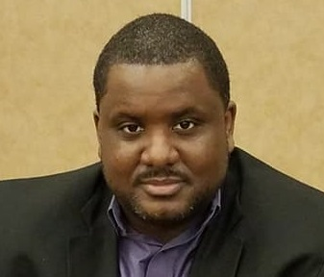

**Tommy J. Curry**

**Personal Chair of Africana Philosophy & Black Male Studies,**

**University of Edinburgh**

**Categorical Fractures: Phallicism as a Challenge to Jim Sidanius’ Account of the Subordinate Male Target in Arbitrary Set Discrimination**

Social Dominance Theory (SDT) remains the most empirically validated account of race and sex interactions across the Western world. Despite its utilization as an explanatory theory in numerous social scientific fields such as economics, psychology, and political science, the humanist sciences have continued to ignore the far-reaching consequences of the subordinate male target hypothesis (SMTH). Black Male Studies (BMS), while in agreement with the view that subordinate males are the primary targets of arbitrary set discrimination, suggests that sexualization and sexual violence against racialized males fractures the trimorphic categories used to describe age, sex, and arbitrary set groups. This presentation aims to show that racialization produces differing phallicistic effects on subordinate male groups that mirror outcomes SDT claim should primarily, if not exclusively, belong to the sex or patriarchal category in their theory. I argue Black Male Studies provides a more explanatory account of racialization than SDT given this finding.

**Everyone Welcome!**

**For accessibility requirements, please contact philosophy@queensu.ca**

**If you are not on our colloquium mailing list, please contact us by email at:**

[**philug@queensu.ca**](mailto:philug@queensu.ca) **to receive updates.**

**Graham Kennedy Memorial Lecture**

Department of Philosophy presents the