This upgrade was mostly on back-end fixes, but there are a few changes outlined below that will change the user experience in FAST.

- Collapsible menus
When you navigate to a report from the financial reporting homepage there is an option to collapse the header menu.

If you choose to collapse the header menu FAST will just show the reports menus. This will hide the return to reports buttons, notifications button, chat button and profile information.

To undue this change, select the collapse button again.

- Return to report changes
The return to report buttons has changed because of the upgrade. The old version of FAST displayed the return to report buttons as below:

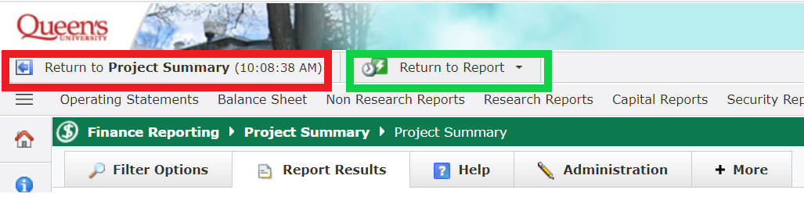
The button outlined in red would return to the last report that was executed. The button outlined in green would allow to search through all reports ran in the current session in FAST. After the upgrade, these are now displayed as below:

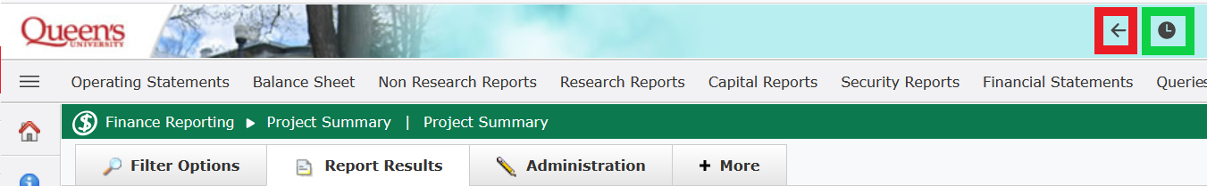

The button outlined in red will return to the last report that was executed. The button outlined in green will allow to search through all reports ran in the current session in FAST.

- Creating pinned reports
When creating a pinned report, the pinned report button now shows “Create” instead of “Save As.”

Old version of FAST
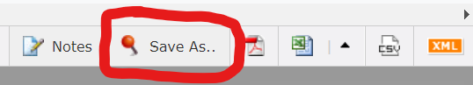

Updated environment
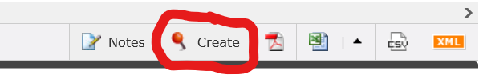

When updating a pinned report, the button remains unchanged.

