This document is to assist you in using ERS to submit travel and expense claims.
As of January 1^{st,} 2021, the use of ERS is now mandatory for all Faculty, Staff and Students. This is as per the Travel and Expenses Reimbursement Policy. If you are unsure if you or someone in your department has access to ERS, please contact expenses@queensu.ca.
If the individual does not have access to ERS, such as visitors and undergraduate students, paper claims can still be submitted.
NOTICES:
- If this is your first time using ERS please see the “First Time ERS Users Guide” to ensure that your account is set up correctly.

- Please note that claims for speaker fees, honorariums, or invoices to be paid for services provided should be processed using AcQuire. For more information on this please contact the AcQuire Support Team at acquire@queensu.ca or Accounts Payable at accounts.payable@queensu.ca.

- Depending on the claimant’s status at the University they may have two accounts. For example, students may have a student account and an employee account. If this is the case, please ensure that you are using the correct account to submit your claim.

- Students are asked to ensure their mailing address and banking information is correct in SOLUS. This is the information that will be used to process your payment.

- If you are a new to ERS or if you are unsure if your address and banking information has been updated, please contact expenses@queensu.ca.

- For steps on how to log in as a delegate for someone else, please see the “Delegates” document.

- The terms “Claim” and “Report” are interchangeable in ERS and this document. Depending on when you were granted access to ERS will determine the terminology used on your ERS account. This cannot be changed.

Accessing ERS
To access ERS:
www.queensu.ca > Search and Sign In > MyQueen’sU > Solus, MyHR and more.
Under the Financial Applications header is the link to ERS. Click on the link and select ‘Log into the ERS’.
You may be prompted to enter in your Queen’s NetID and password a second time. Or you will be taken directly to your ERS homepage.
For detailed instruction on how to log into ERS see the “First Time ERS Users Guide”.
Creating an Expense Report
Claims submitted using ERS can be either travel or expense claims, this includes Professional Expense Reimbursements (PER/PEA). However, as stated previously, any payments being made for speaker fees, honorariums or invoices to be paid for services provided must be processed using AcQuire. If they are submitted using ERS, including a PER/PEA, the claim will be returned.
From your ERS home screen select the ‘Expense’ Tab.

If you have Approver status you will see:

The ‘Requests’ and ‘Approvals’ tabs will be covered in separate documents. The ‘App Centre’ tab is not used by Queen’s University.
When the Expense Tab opens you will be under the ‘Manage Expense’ option and you will see a red box ‘Create New Report’. Select this box.

The ‘Create New Report’ (also known as the Report Header) page will open. You will be required to complete all fields that are marked with a red asterisk *.

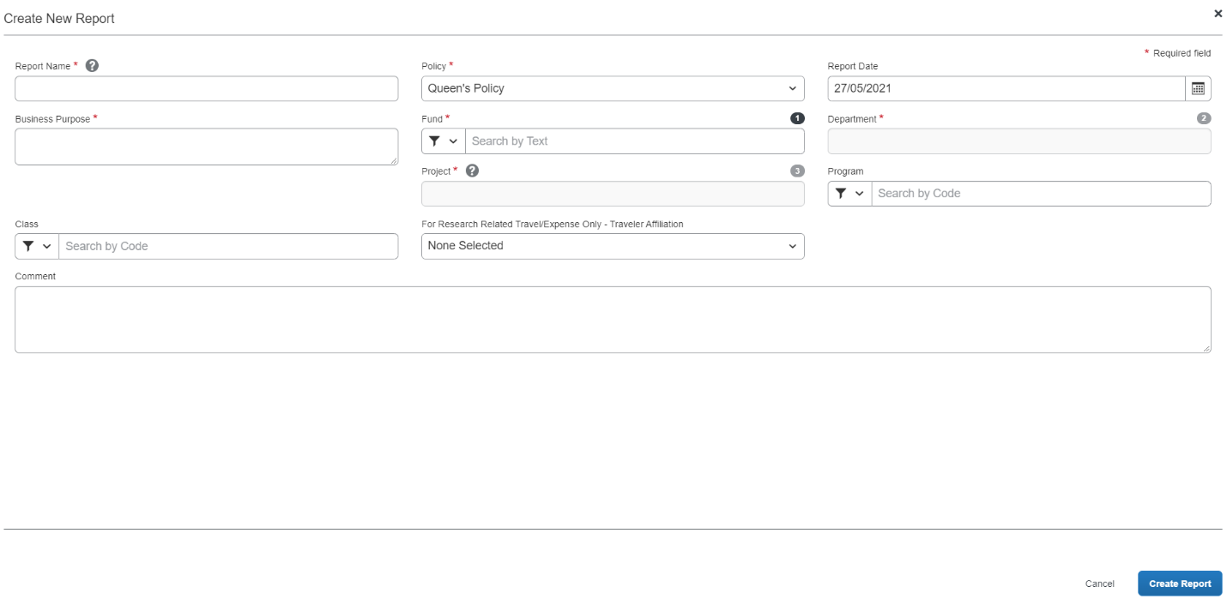

You will need to contact your department to obtain the Fund, Department, Project and if needed the Program and Class codes. These cannot be provided by Financial Services. Your department may have a preferred format for the Report Name.
If you are submitting a claim under a Research Project Code, you will need to select an option from the ‘For Research Related Travel/Expense Only – Traveler Affiliation’ drop down menu.

This is required for all claims submitted using a Research Project code not just travel claims. If this is not completed the claim will be in error and will be returned to you.
There are four options, if you are unsure of which option to choose, please contact your department or Research Accounting at research@queensu.ca:
- Self or the PI of the project
- Co-Investigator
- Student
- Other
Once you have entered in the required information select the ‘Create Report’ button in the bottom right corner.

You will be taken to the Expense page where you will be able to build your claim.
Adding Expenses
Once you have created the claim you will be taken to the expenses page, this is where you will be able to add all expenses that correspond to this claim.
If you have an active Cash Advance, you will see a blue bar across the top of the page. Assigning advances to the claim will be covered later in this document. If this claim does not relate to the cash advance, then ignore this notice.

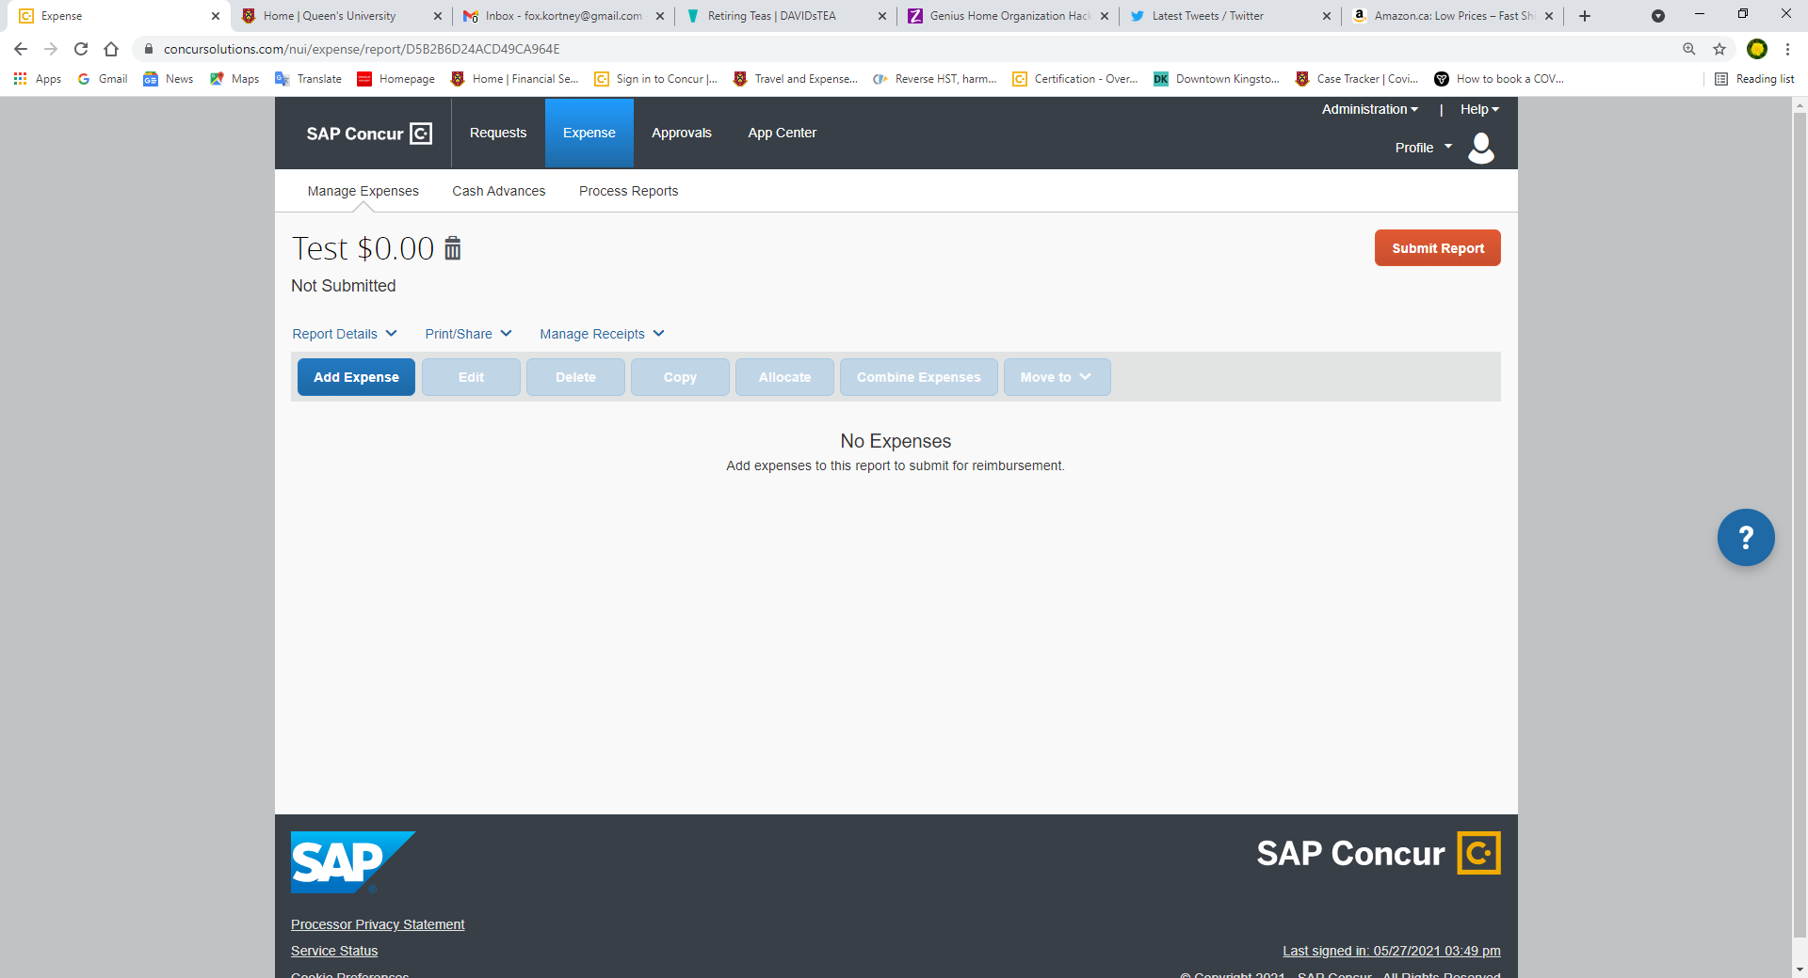

To add a new expense, select the ‘Add Expense’ button.

A window will open with two tabs.
One tab will show any available expense you have added to ERS, either manually or by emailing them to ERS.
The second tab is where you can create expense from scratch.
For more information, please see the “Receipts” document.

No available receipts Available Receipts

Using the ‘Creating New Expense’ Tab
When you select the ‘+ Create New Expense’ tab you will see a list of expenses. Select the expense type that best matches your receipt.
If no expense type corresponds with the receipt, select the ‘Miscellaneous’ expense type. It is asked that it be used sparingly.
For more information on individual expense types please see the “Expense Types” document.
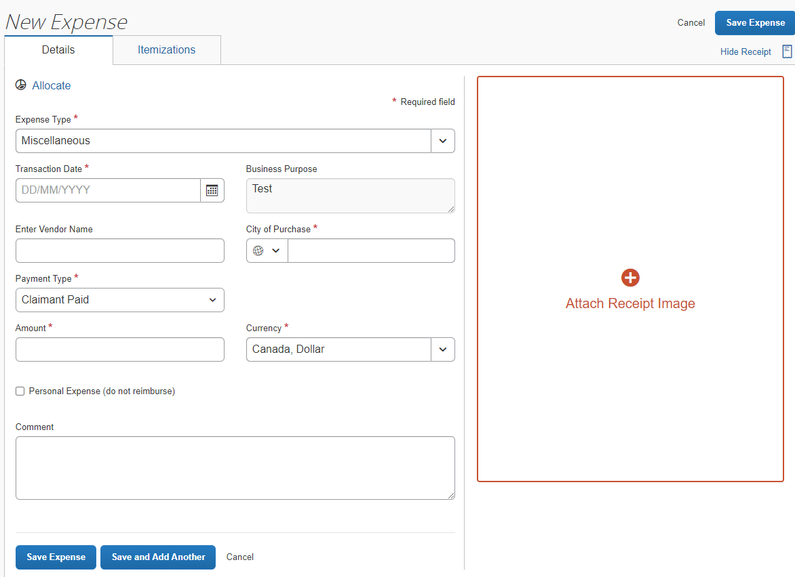

Click on the red ‘Attach Receipt Image’ box on the right. A window will open showing you your available receipt(s) or allowing you to upload one from your computer.
Receipts Available No Receipts Available

You can assign an available receipt by selecting the ‘Attach’ link under the receipt image.
If you are not sure if this is the correct receipt, select the ‘View’ link. The receipt will open in a new window and you will be able to review it.
Example of a receipt being viewed.

If this is the correct receipt, select
the ‘Attach’ button.
If this is not the correct receipt
select the ‘View All Receipts’
option in the top left corner of
the screen, to be taken
back to the previous screen.

Alternatively, you can search your computer for receipts to assign to the expense line by selecting the ‘Upload Receipt Image’ box marked in red. Follow the prompts on your computer to select and upload the receipt.

Once you have selected a receipt it will show on the right side of screen. This allows you to have the receipt image open while you enter the required information marked with a red asterisk *.

If you would prefer you can close the receipt by selecting the ‘Hide Receipt’ button above the receipt on the right-hand side. This will give you more space to see the expense information.

Once you have entered in the required information you can select the blue ‘Save Expense’ or ‘Save and Add Another’ button.

The ‘Save Expense’ button will take you back to the overall claim. Selecting ‘Save and Add Another’ will open a new expense page allowing you to add another expense without exiting back to the overall claim.

NOTE:
- It may take a few seconds for the expense to save and for you to be taken back to the over-all claim or the ‘New Expense’ screen.

- If the City of Purchase is not showing in ERS please enter the closest city in the same province or country, and then add a note to the expense line explaining this. The City of Purchase must be entered correctly for tax and currency conversion purposes.

- When you select ‘Save and Add Another’ the screen looks different than what you see when you create a new expense from the main claim page (image below).

Using the ‘Expense Type’ drop down menu select the corresponding expense type for the receipt, and then complete the expense line in the normal manner described above.

Using the ‘Available Expenses’ Tab
If you have expenses listed under the ‘Available Expenses’ tab, you can select the expense and then the ‘Add to Report’ button in the bottom right corner. The expense will be added to the claim. No further action from you will be required for this expense line.
It is advisable that you open the expense and ensure that all information is correct.

Assigning a Cash Advance or Research Participant Advance to a Claim

If you have an outstanding Cash Advance that should be assigned to this claim you will have to assign it after the claim has been created. Please note that only one Cash Advance or Research Participant Advance can be attached to a claim.

Assigning a Cash Advance and a Research Participant Advance are slightly different:

To assign a Cash Advance:
- Create the claim.
- Go to the ‘Report Details’ drop-down menu.
- Select ‘Manage Requests’ under the Linked Add-Ons option.
  - You will only see active Cash Advance requests.

To assign a Research Participant Advance:
- Create the claim.
- Go to the “Report Details” drop down menu.
- Select “Manage Cash Advances” from the drop-down menu.
  - You will see both Cash Advance requests and Research Participant Advance requests.

The ‘Requests’ page will open and will show ‘No Request Added”.

Select the ‘Add’ button a new window will open; you will see either only Cash Advance Requests or both Cash Advance Requests and Research Participant Advance Requests.

Cash Advance’s available under the ‘Manage Request’ option:

Cash Advances and Research Participant Advances under the ‘Manage Cash Advances’ option:

Once you have selected the Cash Advance or Research Participant Advance to be assigned to the claim, the ‘Add to Report’ button will become active. Select it.

You will be taken back to the ‘Requests’ page, it will list the information regarding the advance. Ensure that it is the correct advance and then select the ‘Close’ button.

If this is not the correct advance, select the advance and the ‘Remove’ button will become active. Select it to remove the advance from the claim. You can then go back and add the correct advance.

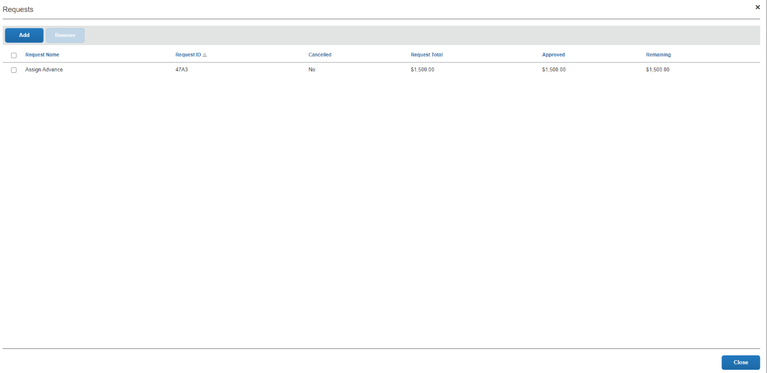

Once the Cash Advance has been successfully added you will be taken back to the main claim page.

You will see a new box titled ‘Request’ and two columns:
- ‘Amount’ showing the total amount of the advance.
- ‘Remaining’ showing the amount that need to be accounted for.

When advance is first assigned Expenses have been added reducing the amount remaining

As you add expenses the ‘Remaining’ amount will decrease. The claim cannot be submitted until this amount is $0.00.

If you have added in all the related expenses and there is still a balance you will need to return the funds to Queen’s University. Please see the “Returning Funds” section below.

Returning Funds to Clear an Advance

If you have not accounted for the total amount of a Cash or Research Participant Advance the balance owing will have to be returned to Queen’s.
Outstanding Cash Advance/ Research Participant Advance amounts can be submitted using one of the following methods:

- E-Transfer – to return the funds using E-Transfer please contact travel.advances@queensu.ca. You will be sent an email with instructions to follow. This is the preferred method.

- Cheque or Money order – The cheque or money order must be made out to “Queen’s University – Kingston” and be attached to a completed “ERS -Cash Advance Return Receipt”. These can be sent via internal mail or Canada Post to the Financial Services office.

- Cash – Cash can be submitted with the “ERS – Cash Advance Return Receipt” to the Financial Services office. DO NOT send cash through internal mail.

Once the funds have been retuned the emailed receipt for the E-Transfer or a copy of the completed and signed “ERS – Cash Advance Return Receipt” can be uploaded using expense type 13. Cash Advance – Cash Advance Return.

Under the ‘Amount’ box enter the amount that was returned to the University.

This will clear the remaining amount of the advance and allow you to submit the claim.

Participant Payment

Amount Remaining Advance Cleared

Once the advance has been cleared the claim can be submitted in the normal manner.

Submitting a Claim

After you have entered and completed all the necessary or required expenses the claim can be submitted. Select the orange ‘Submit Report’ button in the top right corner. The ‘Copy Report’ option will be covered in a separate document.

When you select the ‘Submit Report’ button, the ‘User Electronic Agreement’ screen will open. Please read the agreement and if you agree select the ‘Accept and Continue’ button in the bottom right.

The next screen to open is the ‘Report Totals’. This screen shows how much is to be paid to the company, Queen’s, the claimant and if you have assigned an advance to the claim how much is owed back to Queen’s.

If there are any alerts on your claim they will be displayed across the top of the ‘Report Totals’ window. You can select the drop-down arrow and review them.

After you have ensured that the information is correct select the ‘Submit Report’ button.

The next screen to open is the ‘Edit Approval Flow’ where you will search by your approver.

The 1st Processor or a 2nd Processor do not have to be added, your department may request this, but adding the 1st and 2nd processor can cause the claim to get caught in a cycle of approval.

You must search for your approver by LAST name. If the last name is hyphenated, you may have to try the names together and then separately.

Select the name of your approver from the list generated and then select the ‘Submit Report’ button in the bottom right corner.

If you cannot find your approver in ERS please contact Anthony Bose, ajb19@queensu.ca.
When the claim is submitted you will see a small box at the bottom of the page. This is telling you that the claim was submitted successfully.

At the top of the screen, you will see the ‘Report Status’ window. This window will show you that the claim was submitted successfully and the total.

When you click ‘Close’ you will be taken back to the main ‘Expenses Tab’, and your claim will now be marked as ‘Submitted’. The main ‘Expenses Tab’ is where you will be able to track the progress of your claim.

Submitted and Awaiting Approval Approved and awaiting final approval from Financial Services

Final Approval given and awaiting
payment processing.

Recalling a Claim

If you submitted a claim by accident or if you forgot to add an expense you can recall the claim.

If final approval has been given, please contact expenses@queensu.ca to see if the claim can be sent back.

To recall a claim, open the claim then select the blue ‘Recall Report’ in the top right of the screen.

A window will open asking you to confirm that you want to recall this claim, select ‘Yes’.

The claim status will update to ‘Returned’ and the ‘Submit Report’ button will be active again. Once you have made your changes you can re-submit.

Printing a One-Page Summary

Printing a one-page summary as a PDF is advisable for tracking and reconciling.

The report can also be printed and attached to the receipts until the claim has been processed and paid, or in some cases kept on file in your department.

Financial Services recommends printing a summary as a PDF so it can be kept along with scanned copies of the receipts on a shared drive. But it is not mandatory and is at the department and claimant’s discretion.

A report can be printed once the claim is submitted, or it can be printed a year later.

To print a one-page summary open the claim and the go to the “Print/Share” drop down menu.

Select the report you wish to print; it will open in a new window.

The second part of the screen:

You can Print, Save as a PDF, or Email the report. Select the option that best suits your needs and follow the prompts.

For more information or assistance using ERS please contact expenses@queensu.ca.

