This is as an introduction to the ERS for first time users. It covers several options that should be taken to ensure you get the most out of ERS.
Please note that you cannot submit a reimbursement for an honorarium, speaker fee or a payment to a third party for a service provided, such as translations, that the claimant paid out of pocket directly to the payee. These are ineligible expenses and must be made directly to the individual using AcQuire for Tax purposes.
If you have any issues or questions, please contact expenses@queensu.ca.
** Students: You may have an employee NetID as well as your student NetID active in ERS. If this is the case it is the responsibility of the claimant to ensure that the correct account is used. Failure to do so may make is impossible for delegates and approvers to complete the needed tasks. If you are unsure, please contact expenses@queensu.ca.
Please Note:
- In this document the words Claim, and Report are interchangeable.
- SAP Concur refers to the company that created and maintains the ERS program, this is whys some individuals will refer to ERS as Concur.

Table of Contents:
- Logging into ERS
- Verify your e-mail address
- Set up a delegate
  - If someone will be creating claims on your behalf
- Set up a default approver for expense or requests
  - If the same individual will be approving all submissions (requests and claims) in ERS
- Set up a default chartfield information.
  - If your claims will all be charged to the same chartfields (account information)

Logging into ERS
- Go the Queen’s Homepage, www.queensu.ca, and select the Search and Sign in button in the top right corner.
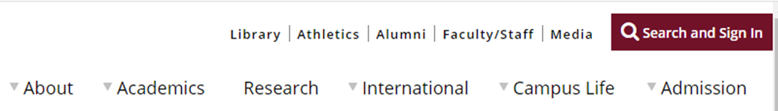

- Select the “MyQueen’sU – Solus, MyHR and More” link

- Scroll down until you see the Expense Reimbursement (ERS)/Concur icon, when you select it a drop down will open. You will need to select the “Log In to the ERS” link.

- Enter in your NetID and password. If your NetID is not recognized please contact expenses@queensu.ca, to see if your ERS account has been deactivated. If your ERS account is showing as active, but your NetID is not allowing you to log in you will have to contact ITS or try an alternative NetID.

- Once you have logged in you will be on the main SAP Concur/ERS homepage. Select the “Profile” dropdown menu seen in the top right corner of your screen. To complete the items in this document you will be working from your profile page.

- From the drop down select “Profile Settings”

- Personal Information - This is a recommend but not required step

From your Profile Settings, select the “Personal Information” link in the main section or the list on the left.
Since this is your first-time logging into ERS it is recommended that you go through the Personal Information screen and ensure that all information is correct. This will also be the starting point for any updates to your account that need to be made.
If you are a Graduate Student who has a Student and Employee NetID for logging in, please make note which of the two you are using.
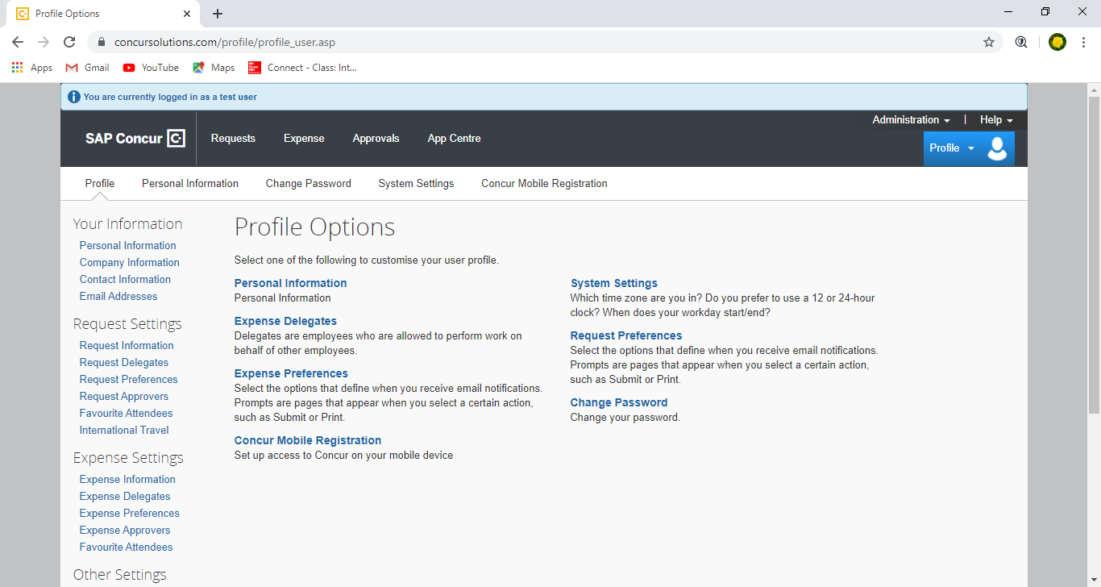

Verify your Email Address
When you verify your email address you will:
- Have the option to receive emailed update on the status of your claim.
- Be able to email receipts to receipts@concur.com, they will be uploaded to your ERS account where they will be located under Available Receipts (aka Receipt Store). This is especially useful if you are traveling a lot as you will not have to scan receipts one by one when travel is completed.

- From the list on the left select the Email Addresses link.

- You will be taken to the Email Address Section of your Personal Information.

- You will see an email that has been associated with your ERS Account, you can verify this email or add a different one (including gmail). If you have two email address, we recommend verifying the one you use most. You can have more than one email attached to your account.

- Select the Verify link.

- A window will open stating that an email was sent to the email address you have entered. Select “Okay”

- A code will be emailed to you. This code will need to be entered into the “Enter Code” box that opened. Please note that it may take several minutes for the email to appear in your inbox. Please be sure to check your SPAM folder.

- The code you are emailed will be approximately 20 characters long and will be a mixture of letters and numbers.

- Copy and paste the code in the box provided and select OK

- A new window will open telling your that your email address has been verified.

- When you click on OK you will see a green circle with a check mark in it, this means you were successful in verifying your e-mail address.

- You can now email receipts to receipts@concur.com and they will be added to your account, you will also receive emails to update you on the status of your claim.

Setting up a Delegate
A delegate is someone who can act on your behalf to prepare and submit Cash Advance Requests, Research Participant Advance Requests or Travel and Expense Claims. As the user you will be able to assign the tasks that they are allowed to perform. This is an optional step; you do not have to set up a delegate.
- To set up a delegate log into ERS, and go to your Profile

- From the drop down select “Profile Settings”

- From the lists on the left select Request Delegates or Expense Delegates, the process of adding a delegate is the same for both options. For this document we will be using the Expense Delegate option.

- A new screen will open, there should be no names currently listed.

- Select the “Add” button.

- Once you have selected “Add” a new box will open. This is where you will search for the individual you want to add as your delegate. Please note you will need to search by LAST name.

- A drop down will open, continue typing until you see the name of the individual or scroll through the list to find them. Once you have found their name select it.

Please note that there may be a slight delay when you are typing. This can cause the curser to move. If this happens you will have to reselect the box to continue typing. It is known issue with ERS.

- After you have selected the individuals name, it will show in the list shown under step 5, however none of the check boxes will be selected.

- You will need to select the appropriate check boxes for your delegate:
  - “Can Prepare” gives the delegate the right to create claims for you.
  - “Can Submit Claims” give the delegate the right to submit claims on your behalf.
  - “Can Submit Requests” gives the delegate the right to submit Advance Requests on your behalf.
  - “Can view Receipts” this box is activated when “Can Prepare” is selected. This allows the delegate to view the receipts that you have uploaded.
  - “Receive Emails” allowed ERS to send updates via email to your delegate.
  - “Can Approve” this will only be active if you have approver status, and you will only be able to add an individual who is also an approver. This box gives your delegate the ability to approver claims on your behalf.
  - “Can Approve Temporary” this will only be active if you have approver status. You can set a timeline for when your delegate can approve for you. This option is recommended for vacations.
  - “Can Preview for Approver” allows your delegate to review claims submitted for approval but does not give them the ability to approve. This is effective for budget checking.
  - “Receive Approval Emails” will allow you delegate to receive Emails from ERS regarding any approvals.

- Once you have made your selection, click on the “Save” button, a notice will open indicating that your changes have been saved.

- You can remove a delegate by deselecting the checkboxes and then saving.

Setting up a Default Approver for Expenses or Requests
This is recommended if all your claims and requests will be submitted to the same individual. However, if you are cross-appointed or working under various projects this may not be ideal.
ERS will automatically submit each claim and request to the same individual regardless of the chartfield information entered. You will not be asked to select an approver when you submit a claim or request.
- To set up a default approver, log into ERS, and go to your Profile

- From the drop down select “Profile Settings”

- Go to select the “Expense Approvers” option from the “Expense Settings” menu on the left.

- A new window will open, and you will be able to set up your Approver for Travel and Expense claims and Research Participant Payment Advance Requests at the same time. Search for your approver by their last name and select from the list generated.

- Once you have made your selection, click on the “Save” button, a notice will open indicating that your changes have been saved.
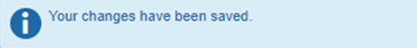

- To set up your Request approver, select the “Request Approvers” from the “Request Settings” menu on the left.

- A new window will open, and you will be able to search for your approver by last name. Select the name from the list generated.

- Once you have made your selection, click on the “Save” button, a notice will open indicating that your changes have been saved.

Setting up Default Chartfield Information
You can set up a default Chartfield (or accounting information) string for your Travel and Expense reports. When you do this, you will always be using the same Fund, Department, and Project coding. You will not have to enter this information into every new claim you create.
NOTE: Please contact your department to verify the Chartfield Information that you should be using.
You will not be asked to set a Program or Class, if these are required for a claim you will have to manually add them to each claim.
- To set up a default chartfield information, log into ERS, and go to your Profile

- From the drop down select “Profile Settings”

- Go to select the “Expense Information” option from the “Expense Settings” menu on the left.

- A new window will open. You will have to start typing in the Fund you want to use and then select from the drop-down menu. If you do not select from the drop-down menu, you will not be able to move on to department selection.
For this document we will be using Operating chartfield information.

- Once you have selected the Fund the Department box will become active. Start typing the Department number and select from the drop-down menu.

- Once you have selected the Department the Project box will become active. If using an operating account, the project will be entered as 000000. If you will be claiming expenses using a research project, then you will have to enter in the code give to you by your department or Research Accounting. Select the correct code from the drop-down menu.

- Select Save. A notice will open indicating that your changes have been saved.

The default Chartfield information you have entered can be updated if needed.
NOTE: The Fund, Department and Project fields must ALL be completed. If one is missing you will receive an error message and you will not be able to create and submit a new claim. Please ensure that all three boxes are filled, or if you do not have all the information remove the numbers until you have acquired all three.

Set up your Mobile App (for Concur Mobile)

For information on how to use the SAP Concur Mobile App, please see the Android or iPhone Mobile Documents located on the Financial Services Website.

If you have any additional questions or concerns, please contact expenses@queensu.ca.

