Once you have completed all actions (i.e., travel or research participant payments) the Advance must be accounted for in full. If there are any funds remaining, they will have to be returned to the University.
As per the Travel and Expenses Reimbursement Policy, cash and research participant advances must be cleared 15 days after their end date. If by 30 days, the advance has not been accounted for you will receive a reminder email and every subsequent month until the advance has been accounted for.
To assign the Cash/Research Participant Advance to a claim:
- Log into ERS using the following path: www.queensu.ca > Search and Sign In > MyQueen’sU -SOLUS, MyHR and More
  - For more information, see the “ERS First Time Users Guide”.
- Under the Financial Applications header you will see the link to ERS, click on the link and then select “Log into the ERS”.
  - You may be prompted to enter in your Queen’s NetID and password.
- From your ERS homepage go to the ‘Expense’ tab.
- Under the ‘Expense’ tab select the red “Create New Report” box.

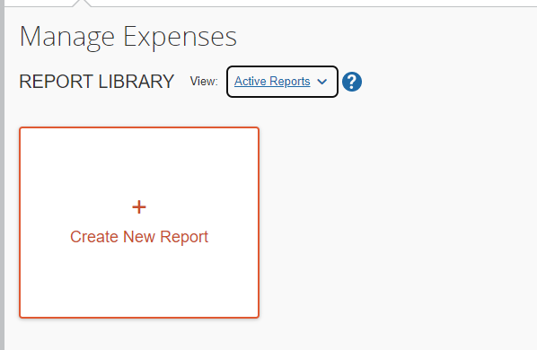
NOTE: The terms “Claim” and “Report” are interchangeable in ERS and this document.
- The ‘Report Header’ will open. You will need to enter all information that is marked with a red asterisk *, then select the ‘Create Report’ button in the bottom right corner.
NOTE: You will need to obtain the Fund, Department, Research Project, and if required, the Program and Class numbers from your department. They cannot be provided by Financial Services.
You will be taken to the main claim page where you will manually have to assign the advance to the claim.
- Go to the ‘Report Details’ drop-down menu on the left side of the screen.

  - From the menu select ‘Manage Cash Advances’ found under the ‘Linked Add-ons’ sections. This will allow you to see both Cash Advances and Research Participant Advances.

- The ‘Cash Advance’ window will open, in the top left corner you will see an ‘Add’ button, select it.

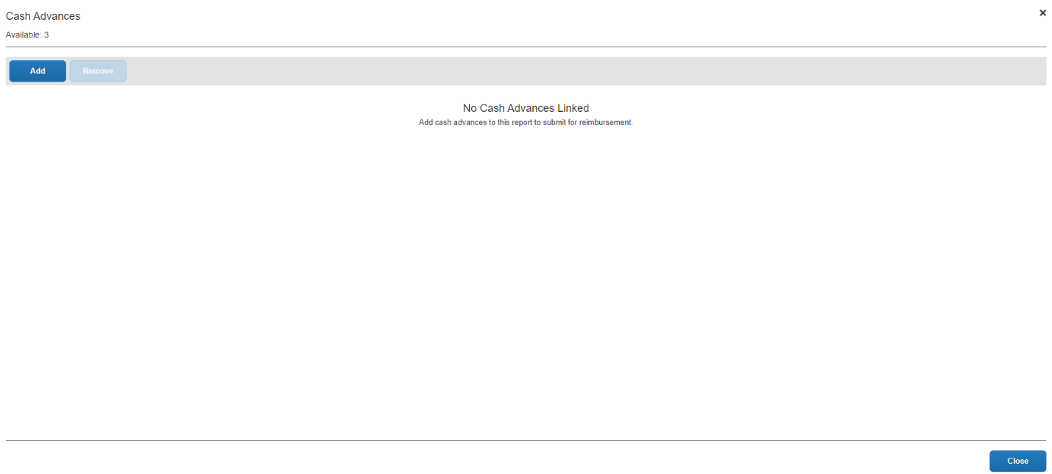

- The ‘Available Cash Advances’ window will open and all Cash and Research Participant Advances you currently have active will be listed.

- Select the one that corresponds to this claim to activate the ‘Add To Report’ button, then select it.

- You will be taken back to the ‘Cash Advance’ screen, where the advance will be listed allowing you the opportunity to verify that this is the correct advance.
  - If it is not the correct advance, select it to activate the ‘Remove’ button. After you select the ‘Remove’ button, the advance will be detached from your claim, and you will have to follow the process above to attach the correct advance.
- Once you have ensured that this is the correct advance close this window using the ‘Close’ button in the bottom right corner to be taken back to the claim.
- There will now be a ‘Cash Advance’ box with two columns.
  - The ‘Amount’ column shows the total amount of the advance.
  - ‘Remaining’ shows how much of the advance has yet to be accounted for.
  - As you add expense the ‘Remaining’ amount will decrease but ‘Amount’ will remain constant. The claim cannot be submitted until the ‘Remaining’ amount has reached $0.00.

- Please include as much information as possible when adding expense details, such as original receipts whenever possible.
- If the participant’s information is confidential, a participant identifier should be assigned to each participant. Please include the assigned participant identifier, the amount of advance paid and the date of payment.
- Confidential information must be kept by the department, such as names, address and SIN, in case of audit.
- Please also include a brief explanation of what the payments are for and how they relate to the research being conducted.
- If research participant payments made to individuals are $500 or more in a calendar year, the department is responsible for collecting information so a T4A can be issued. This information includes the participant’s full legal name, address, and Social Insurance Number. This information must be provided to Financial Services in a secure manner by the first week of January of the following calendar year.

- Once all applicable expenses have been added (Participant payments under 11. Cash Advance- Research Related, Participant Payment), all exceptions cleared and the ‘Remaining’ amount has reached $0.00 the claim can be submitted in the normal manner.
If part of the Cash Advance has not been accounted for it will have to be returned to the University. See the ‘Returning an Unused Cash Advance’ section below.

Returning an Unused Cash/Research Participant Advance Amount
If the entire advance has not been used the remaining amount will have to be returned to the University in full.
Unused Cash/Research Participant Advance amounts can be retuned in one of three ways:
- Electronic transfer. To initiate an electronic transfer or e-transfer email Accounts Receivable at fsaccrcv@queensu.ca. In the email, note that this is a repayment of an unused Cash/Research Participant advance amount.
- Cheque or Money Order. Cheques and money orders must be made out to “Queen’s University - Kingston” and submitted with the “ERS – Cash Advance Return Receipt” the cheque or money order can be sent to the Financial Services office using Canada Post, courier services or internal mail.
- Cash. We ask that cash be brought directly into the Financial Services office and NOT sent by internal mail or Canada Post. Cash must also be submitted with the “ERS – Cash Advance Return Receipt” as well.

NOTES:
- Ensure that your email is noted on the “ERS – Cash Advance Return Receipt”. If you have not provided your email Financial Services will not be able to email you a copy of your receipt to be attached to the claim.
- The Financial Services address is:
Financial Services
355 King St. E. 3rd Floor
Kingston, ON K7L 3N6

Once the funds have been returned and you have received a copy of the “ERS - Cash Advance Return Receipt” or emailed confirmation of the electronic transfer you can complete the claim.

When a cash or research participant advance is assigned to a claim it activates the ‘Cash Advance Return’ expense type. Select this expense type.

The expense type will open and the only field you will need to complete is the amount field. Enter the amount you returned and then attach the completed return receipt or the emailed confirmation for the electronic transfer.

The ‘Cash Advance’ column should now show $0.00 under ‘Remaining’.

Your claim can now be submitted.

Submitting a Claim

Once you have accounted for the balance of the cash/research participant advance you can submit the claim by:

- Select the orange ‘Submit Report’ button in the top right corner.
- The ‘User Electronic Agreement’ window will open if you agree click on the ‘Accept & Continue’ button in the bottom right corner.
- The ‘Report Totals’ window will open. Ensure that the information is correct and there are no alerts marked in red before selecting the ‘Submit Report’ button in the bottom right corner of the window.
- The ‘Edit Approval Flow’ window will open. Under the ‘Manager Approval’ window you will search for your approver by LAST name.
  - If your approver’s last name is hyphenated, you may have to search with and without the hyphen or by each name separately.
  - If you cannot find your approver in ERS please contact finance.security@queensu.ca for assistance.

- Select your approver from the list generated and then the ‘Submit Report’ button.
- The ‘Report Status’ window will open showing the status as submitted. When you click on the ‘Close’ button you will be taken back to the ‘Manage Expenses’ tab, where the claim will now show as ‘Submitted & Pending Approval’.

If you require more information or clarification, please contact expenses@queensu.ca.

