ARTH812: Head and Hand: Craft, Knowledge, and the Body

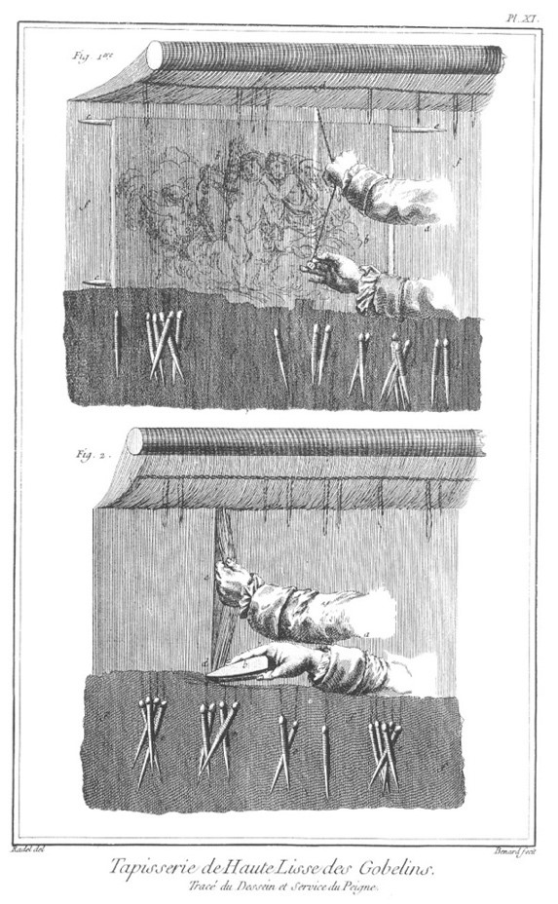
Denis Diderot et D'Alembert,"Tapisserie de haute-lisse des Gobelins," Supplément à l'Encyclopédie ou Dictionnaire raisonné des sciences, des arts et des métiers, vol. 9 (plates). Paris, 1765.

Course Description:
What does it mean to think of art as both object and process? Partly it means reflecting on how the contributions of the “head” and the “hand.” In this course, we will consider the relationship between material things and ideas, between mind and body. Drawing on frameworks including craft theory, comparative aesthetics, and material culture, we will consider questions such as: an object might be read as a source of cultural and historical knowledge and how artists, designers, and craftspeople draw on and materialize knowledge in objects through processes of making. Questions we will consider include: What is the relationship between theoretical knowledge and experience? What kinds of knowledge are there and how are they expressed? How does knowledge take visual, kinetic, or material form?

In addressing these and related questions, the course takes a wide comparative approach, defining art broadly and looking at case studies from across time and in global perspective, including: early modern artisanal epistemology, colonial images of craft process and the body at work, and debates about machine vs hand production. Topics to be considered include: skill and process, knowledge transmission, dispossession of knowledge under colonialism, habitus and the body as cultural expression, and technical images. Finally, we will also reflect on the craft of the historian and writing about art and craft. The course will employ with both practical and theoretical modes; in addition to readings in theory and history, students will engage with experiences of making as a mode of inquiry.

