DEPARTMENT OF ART:
ART HISTORY & ART CONSERVATION

Winter Term 2025

ARTH 472/3.0
Art and Global Encounters in Asia, The Americas and Africa, 1492-1954

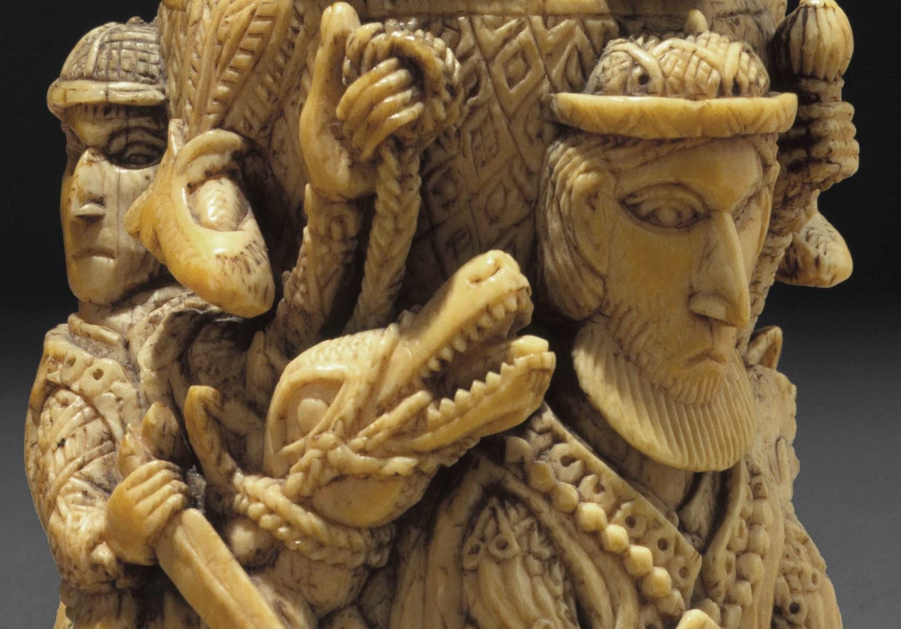

_________________________________________________________________________________

CALENDAR DESCRIPTION:
Offers a critical assessment of hybrid art by focusing on the period of European conquest and evangelization of non-European civilizations from the 15th-20th centuries, a global encounter involving the widest spectrum of peoples, races, cultures, and religions. Will consider the transformation of the arts of Early Modern Europe in contact situations in Asia, Africa, Latin America, and the South Pacific.

COURSE DESCRIPTION:
Explores the art and architecture that resulted from the interaction between European and non-European civilizations from the 15th-20th centuries. This period involved an age of global encounter between the widest spectrum of peoples, representing different ethnicities and religions, as well as political, social, economic, and cultural systems. We will explore the reception of European art and architecture in Asia, Africa, and Latin America, with case studies in Mughal India, Goa, Ming & Qing China, Momoyama Japan, Vietnam, Tahiti, the Nahua (Aztecs), the Quechua (Incas), Paraguay, Ghana, Senegal, Haiti, and Madagascar, among others.

COURSE REQUIREMENTS:
A detailed list of readings and requirements will be available during the first class. The course is a seminar course comprising class discussions, student presentations, and a final paper. Participation is mandatory.

