ARTH377: Modern Design and Materiality

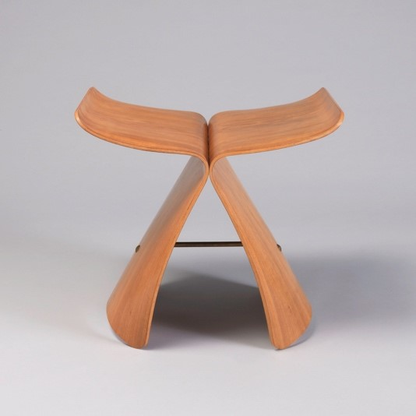
Sori Yanagi, Butterfly Stool, moulded plywood, 1954.
Cooper Hewitt Design Museum
This course will focus on craft and design in the late nineteenth and early twentieth centuries with a focus on materials and materiality. Though often described as ephemeral, the experience of modernity also gave rise to physical manifestations of its values. New material innovations such as wrought iron, chrome plating, plastics, and synthetic textile fibres led many to herald a “new age.” Modernist designers often saw their task as that of “catching up” to these changes by “embracing” technology and showcasing new materials and new processes of material transformation, while those working in the crafts sought to highlight the material qualities of their work. In considering how modernist aesthetics—as well as modernist values—developed in relation to a vocabulary of materials, we will look at three overlapping categories: new materials, new processes, and the new meanings that attached to them. We will consider issues such as global material flows, the relationship between craft and design, the affective, visual, and physical qualities of materials, and how such dimensions interact with nationalism, colonialism, race, history, gender, and class.

