ARTH277: Artists and Artisans in South Asia

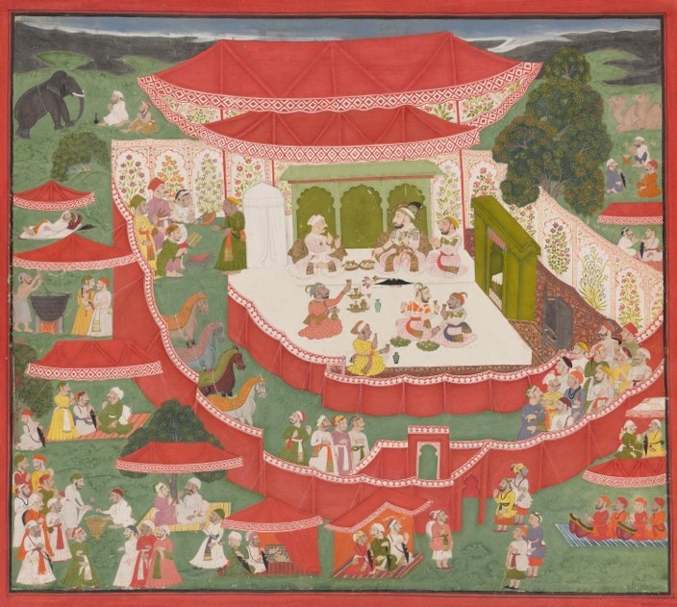

Jai Ram (attributed to)
Maharana Sangram Singh II receiving Maharaja Sawai Jai Singh of Jaipur feasting in camp (c. 1732)
opaque watercolour and gold paint on paper
National Gallery of Victoria, Melbourne

COURSE DESCRIPTION
This course discusses art, craft, and design of South Asia within a global context. We will examine a diverse range of artistic and artisanal works including painting, architecture, sculpture, arts of the book, and sculpture, as well as textiles, metalwork, ceramics, and furniture. We will also consider theories of aesthetics and craftsmanship in South Asian traditions. Considering the histories and meanings of materials, including colour, students will develop skills in material and visual literacy. Following the rise and fall of different empires, we will discuss the relationship between political, social, and economic histories and artistic and artisanal objects.

