DEPARTMENT OF ART:
ART HISTORY & ART CONSERVATION

Fall Term 2024

ARTH 272/3.0
Latin American Art

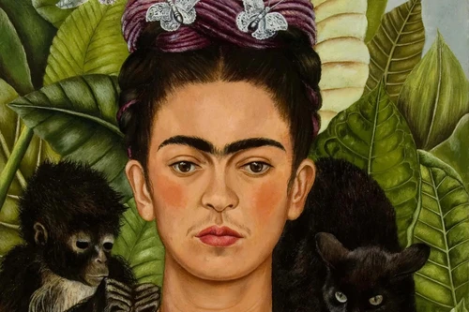

_________________________________________________________________________________

CALENDAR DESCRIPTION:
Surveys the art and architecture of Latin America from the pre-Hispanic period to the present, from Patagonia to California. Particular attention is paid to the contribution of aboriginal artists and traditions to colonial visual culture and the built environment. Considers the rise of the academies, Nationalism, Indigenism, Romanticism, Modernism (Kahlo, Rivera, Tarsila), Madí and Chicano muralism.

COURSE DESCRIPTION:

Explores the art and architecture of Latin America, from Argentina to the Caribbean and Southeastern United States, from ca. 1200 BCE to the present. The course will look at the great civilizations of pre-Hispanic America (Olmecs, Maya, Aztecs, Moche, Inca and others), colonial Latin America (Spanish America, from New Mexico to Patagonia, and Portuguese Brazil), and the arts from Independence in the early 19th century to the present, including a consideration of key figures such as Frida Kahlo, Diego Rivera, Wifredo Lam, and Tarsila do Amaral.

COURSE REQUIREMENTS:
A detailed list of readings and requirements will be available during the first class. The course is a lecture course with regular readings from a textbook and on OnQ, regular mini essays, and a final paper.

