DEPARTMENT OF ART:
ART HISTORY & ART CONSERVATION

Fall Term 2024

ARTH 121/3.0
Global Art Histories: Parallels & Contacts

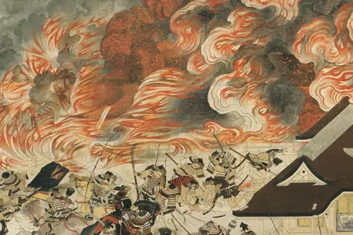

_________________________________________________________________________________

CALENDAR DESCRIPTION:
An introduction to the study of art, architecture, and material culture from a global perspective, including Asia, Europe, Latin America, and Africa. Organized around themes, parallels and connections will be drawn between artistic objects and buildings from across history and around the world. Case studies consider art and architecture’s relationship to religion, monarchy, colonialism, indigeneity, missionization, cultural appropriation, commodification, and self-representation. Others will consider medium, technique, perspective, composition, and art’s relationship to narrative and meditation.

COURSE DESCRIPTION:
An introduction to the study of art, architecture, and material culture from a global perspective, including Asia, Europe, Latin America, and Africa. Organized around themes, parallels and connections will be drawn between artistic objects and buildings from across history and around the world. Case studies consider art and architecture’s relationship to religion, monarchy, colonialism, indigeneity, missionization, cultural appropriation, commodification, and self- representation. Others will consider medium, technique, perspective, composition, and art’s relationship to narrative and meditation. Students will develop fundamental skills of analysis, written communication, and research applicable to many arts and humanities disciplines. Rather than attempting a comprehensive survey of global art this course provides the framework for more in-depth explorations in the visual arts.

COURSE REQUIREMENTS:
A detailed list of readings and requirements will be available during the first class. The course is a lecture course with regular readings posted on OnQ, tutorials, short essays, and a final paper.

