DEPARTMENT OF ART HISTORY & ART CONSERVATION

Fall Term 2024

ARTH: 485: A Social and Material History of Italian Renaissance Sculpture

ARTH 842: Studies in Italian Renaissance Art II

Crafting Flesh: Collaboration in the Creation of Multimedia Sculptures in the Renaissance
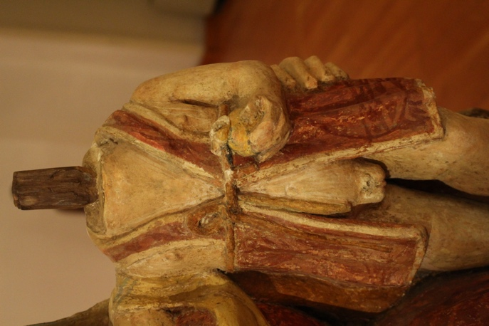

COURSE DESCRIPTION:
When we think of Italian Renaissance sculpture, a white marble statue often comes to mind – Michelangelo’s David or Vatican Pietà perhaps – or maybe a work bronze, such as Donatello’s David. We celebrate the genius artist, who is often assumed to work alone to create a masterpiece. We also focus on a few famous centers of production: Rome, Florence, and Venice, ignoring the rich traditions of northern and southern Italy. But many Renaissance sculptures in all regions of Italy are the work of multiple workshops and made of an astonishing variety of mixed materials: wood, clay, leather, cement, plaster, wax, cork, iron, hair, hemp, glass, fabric, paint, gold, and other substances, both expensive and cheap. The workshops were almost exclusively staffed by men, but women also collaborated in creating many of these sculptures, by dressing them in real fabric clothing and adorning them with actual jewels. In this course, you will carry out your own original research into how multimedia objects were created, with opportunities to carry out physical experiments in the use of diverse media. You will work collaboratively with your peers to research, write, curate, and publish a digital exhibition that reveals this colorful, collaborative side of Renaissance art.

Marks Allocation
The course requirements will include carrying out original research and working collaboratively to curate an online exhibition, which will be published at the end of the course.

