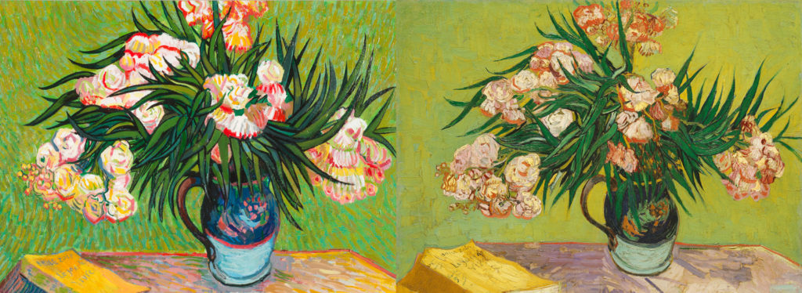

DEPARTMENT OF ART HISTORY & ART CONSERVATION

ARTH391 – ART FORGERIES
Winter 2024

CALENDAR DESCRIPTION:
This course examines forgeries of visual materials and their impact on society through an interdisciplinary approach taking into consideration history, economics, law, and science.

PREREQUISITES: Level 3 or above.

COURSE DESCRIPTION:
Forgeries have an incredible allure. As with a conjuring trick, we are bemused when we are fooled, especially when our own finances and reputations are not involved. However, on a societal level, rarely do we investigate this phenomenon in more than a superficial manner resulting in little understanding of the depth of a fake’s impact. This class will delve more fully into the world of art forgeries to provide a more detailed and comprehensive understanding of their history, production, identification, and reception. In order to encapsulate the nuances of this phenomenon, this class will take an interdisciplinary approach, including guest lectures, to foster discussion about the impact of art forgeries on a wide range of disciplines including art history, finance, law, museology, and conservation. Through interdisciplinary dialogue, students will attempt to form their own philosophical approach to forgeries based on their fields of study in combination with art history.

LEARNING OUTCOMES:
To complete this course, students will demonstrate their ability to:
1. Describe and explain the impact of forgeries and be able to discuss the place of
forgeries in history using appropriate vocabulary
2. Apply theoretical and historical knowledge to the phenomenon of fakes to determine and illustrate an understanding of the complexity of forgeries in our interconnected world, conveying that knowledge appropriately in oral and written formats
3. Critically analyze issues of how society can deal with forgeries economically, legally,
scientifically, historically, and as part of museum practice
4. Compare and contrast approaches of various disciplines to the complex, multi- faceted phenomenon of forgeries
5. Develop their own philosophical approach to forgeries, defend their ideas, and create
their own solutions to dealing with fakes that reflects art historical considerations as well as ideas from their own fields of interest

EVALUATION:
20% - Attendance, Participation, and Opinion Surveys
45% - Three Position papers [Each one = 15%]
35% - Final Research Paper

