DEPARTMENT OF ART HISTORY & ART CONSERVATION
ARTH 260/3.0 (W 2025) Culture and Conflict

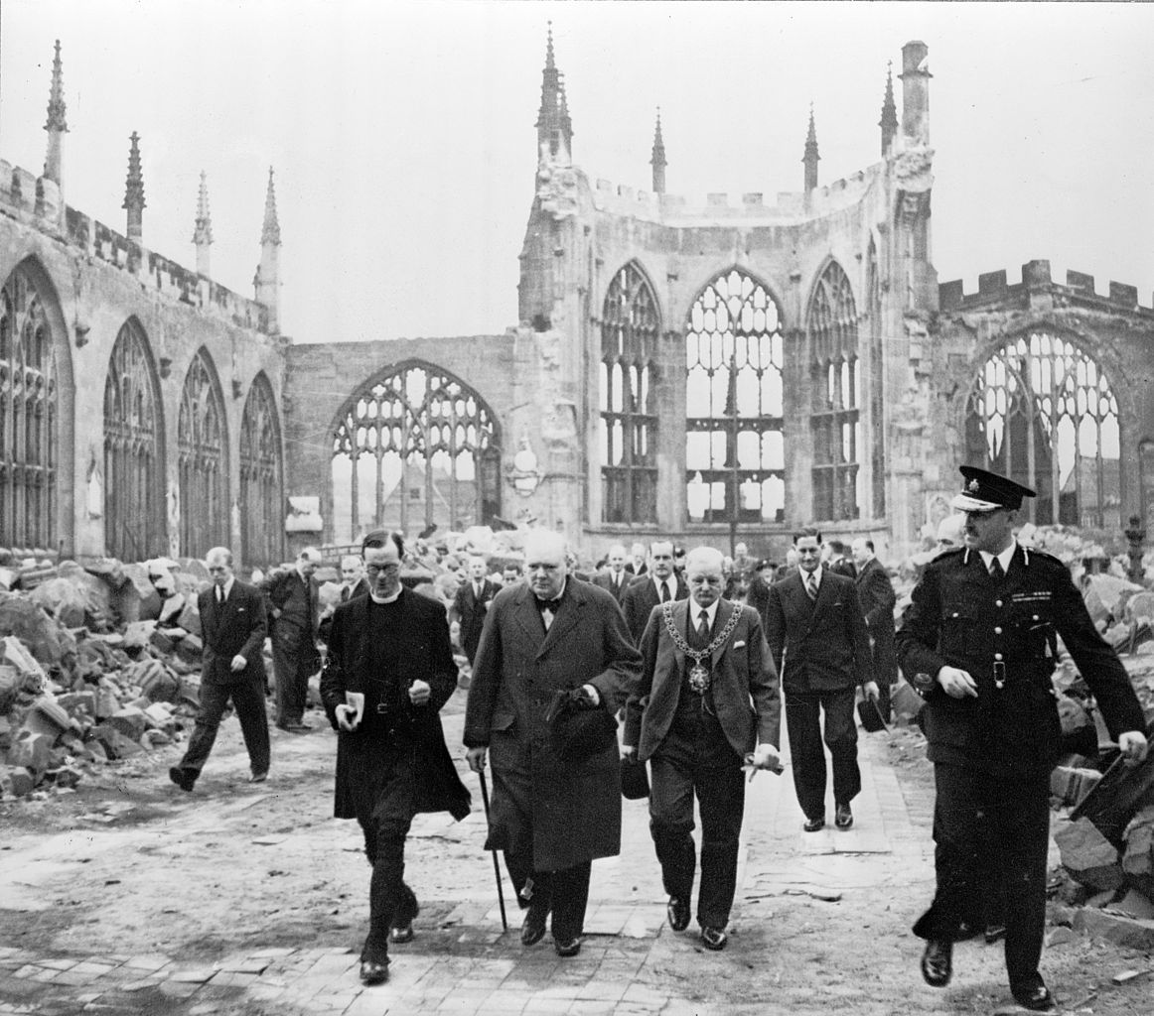

______________________________________________________________________________
CALENDAR DESCRIPTION: An investigation of the impact of war on art and architecture, as well as human attempts to preserve cultural heritage. A chronological or thematic approach may be taken, with focus placed on one or more case studies, such as: the Sacks of Rome, the Napoleonic wars, Nazi looting, the Cultural Revolution in China, Afghanistan under Taliban rule.
PREREQUISITES: Level 2 or above or permission of the Department.
COURSE DESCRIPTION: From the ancient world to Syria and Ukraine today, we examine the impact of military conflicts on art and architecture over the centuries and from a global perspective. Among the topics are: art looting during war, the restoration of damaged monuments, and attempts to protect heritage from destruction.
COURSE REQUIREMENTS: ARTH 260 is a lecture course, and there will be a 3-hour class each week. The power-point images from the lectures will be posted. Students have weekly required readings via Course Reserves. Every two weeks there is a multiple-choice quiz via onQ and based on the lectures and readings. One research essay is required, and there is a 3-hour final exam in the exam period.

