**DEPARTMENT OF ART**

**ART HISTORY & ART CONSERVATION**

ARTH215/3.0

Renaissance Art and Architecture after 1500: Popes, Princes, and Prostitutes

Winter 2024

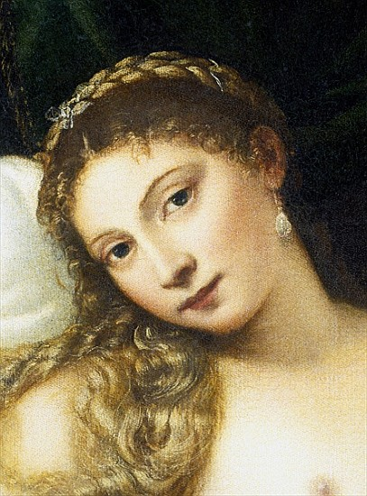

_________________________________________________________________________________

CALENDAR DESCRIPTION: A study of Renaissance art and architecture after 1500 within the context of the social, political and economic history of Western Europe. Key monuments, themes and concepts will be stressed.

*Prerequisites*: Level 2 or above or permission of the Department.

COURSE DESCRIPTION:

This course examines both some of the most famous works of such artists as Leonardo da Vinci, Raphael, Michelangelo, and Albrecht Dürer, as well as lesser-known works that allow for alternate histories of the Renaissance. By examining images of muscular heroes, demure brides, sweet babies, howling witches, and prostitutes, among others, we will explore the ideals, realities, power structures, and marginalized peoples of this complex society, one that was foundational for how we today commemorate our heroes, build our cities, envision ideals of masculinity and femininity, and imagine the divine. The Renaissance was an age like ours in that it was a time of rapid change and violence, but unlike ours in that art was not confined to museums. Art was used to aid devotion, as decoration, political propaganda, a reminder of a dead loved one, a diplomatic gift, erotica, an almost magical totem, a collectable, or even a form of punishment. We will look at art for popes and princes, as well as works made for and by powerful women. Issues to be discussed include the gender, sexuality, changing notions of what was licit, concepts of beauty and ugliness, and the relationships among art, science, religion, literature, philosophy, and politics.

INTENDED LEARNING OUTCOMES:

By the end of this course, students will:

1. be able to identify and discuss major works of Renaissance art from ca. 1500 onwards.

2. analyse a work of art and make an original argument in correct and clear prose using written primary sources.

3. demonstrate an understanding of how specific works of art functioned as a part of the lives of the men and women who commissioned, created, and viewed them.

4. relate specific examples to broader issues, such as gender roles in the Renaissance.