This document is to assist you in using ERS to submit travel and expense claims.
As of January 1st, 2021, the use of ERS is now mandatory for all Faculty, Staff and Students. This is as per the Travel and Expenses Reimbursement Policy. If you are unsure if you or someone in your department has access to ERS, please contact expenses@queensu.ca.
If the individual does not have access to ERS, such as visitors or undergrad students, paper claims can still be submitted.
NOTICES:
- If this is your first time using ERS please see the “First Time ERS Users Guide” to ensure that your account is set up correctly.

- Please note that claims for speaker fees, honorariums or invoices to be paid for services provided should be processed using AcQuire. For more information on this please contact the AcQuire Support Team at acquire@queensu.ca or Accounts Payable at accounts.payable@queensu.ca.

- Depending on the individual’s status at the University they may have two accounts, most notably would be students who have a student account and an employee account. If this is the case you will need to be careful to ensure that the correct account is being used.

- Students are asked to ensure their mailing address and banking information is correct in SOLUS. This is the information that will be used to process your payment.

- If you are a new ERS user or if you are unsure if your address or banking information has been updated, please contact expenses@queensu.ca.

- For steps on how to log in as a delegate for someone else, please see the “Delegates” document.

- Please note that the terms “Claim” and “Report” are interchangeable in ERS and this document. Depending on when you were granted access to ERS will determine the terminology used on your ERS account. This cannot be changed.

Accessing ERS
To access ERS follow this path:
www.queensu.ca > Search and Sign In > MyQueen’sU > Solus, MyHR and more.
Under the Financial Applications headers is the link to ERS. Click on the link and then select the ‘Log into the ERS’ option.
You may be prompted to enter in your Queen’s NetID and password a second time. If not you will be taken directly to the ERS homepage.
For detailed instruction on how log into ERS this please see the “First Time ERS Users Guide”.
Creating an Expense Report
Claims submitted using ERS can be either travel or expense claims, including Professional Expense Reimbursements (PER or PEA).
However, as stated previously, any payments being made for speaker fees, honorariums or invoices to be paid for services provided must be processed using AcQuire. If they are submitted using ERS, including on a PER/PEA, the claim will be returned.
From your ERS home screen select the ‘Expense Tab’.
- You will also see a ‘Request’ tab and if you have approver authorization you will see an ‘Approver’ tab, these will be covered in separate documents.

- The ‘App Center’ tab is not used by Queen’s.
When the ‘Expense’ tab opens you will be under the ‘Manage Expenses’ option. You will see a red box ‘Create New Report’. Select this box.
The ‘Create New Report’ (formally known as the Report Header) page will open. You will be required to complete all fields that are marked with a red asterisk *.
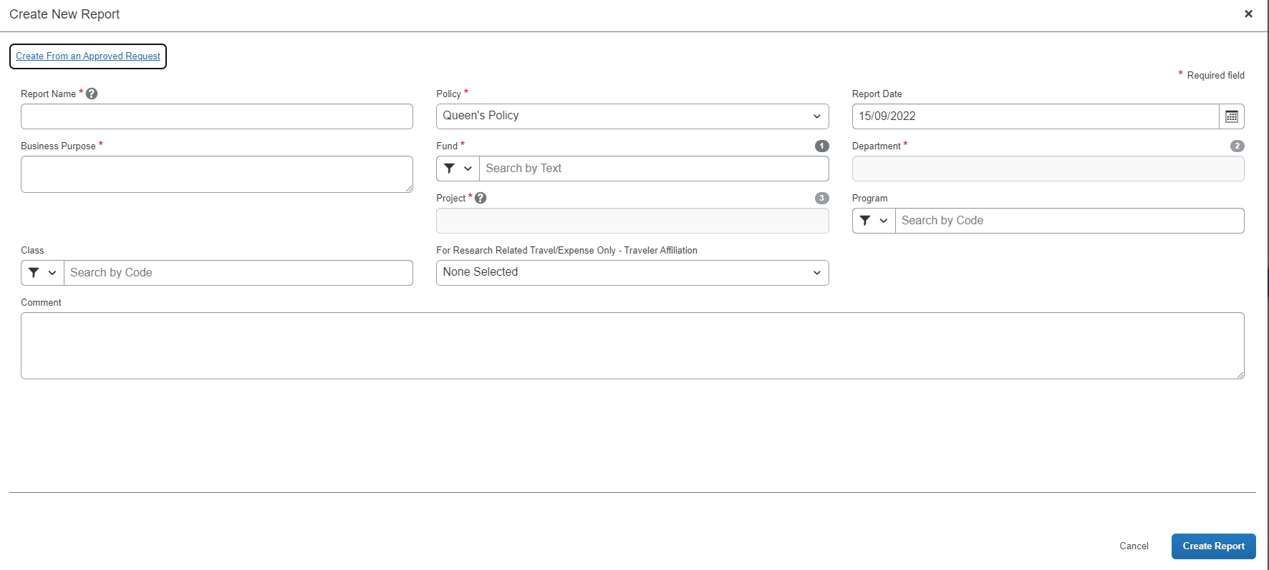
You will need to contact your department to obtain the Fund, Department, Project and if needed the Program and Class codes. These cannot be provided by Financial Services.

Your department may have a specific format for the Report Name.

If you are submitting a claim under a Research Project Code, you will need to select an option from the “For Research Related Travel/Expenses Only – Traveler Affiliation” drop down menu.
- This is required for all claims submitted using a Research project code not just travel claims. If this is not completed the claim will be in error and will be returned to you.

- There are four options, if you are unsure of which option to choose, please contact your department or Research Accounting at research@queensu.ca:
- Self or the PI of the Project
- Co-Investigator
- Student
- Other
Once you have entered in the required information select the ‘Create Report’ button in the bottom right corner.
You will be taken to the Expense Page where you will be able to build your claim.

Adding Expenses
Once you have created the claim you will be taken to the expenses page. This is where you will be able to add all expenses that correspond to this claim.
If you have an active Cash Advance, you will see a blue bar across the top of the page. We will cover adding advances to the claim later in the document. If this claim does not relate to a cash advance this can be ignored.
To add a new expense to the claim, select the ‘Add Expense’ button.
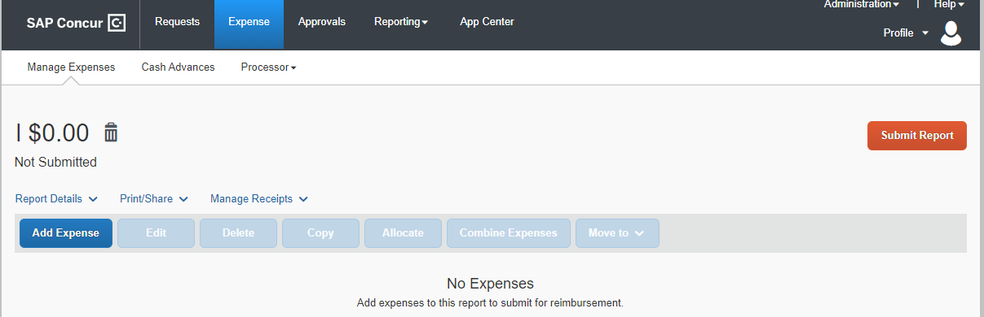
A window will open with two tabs.
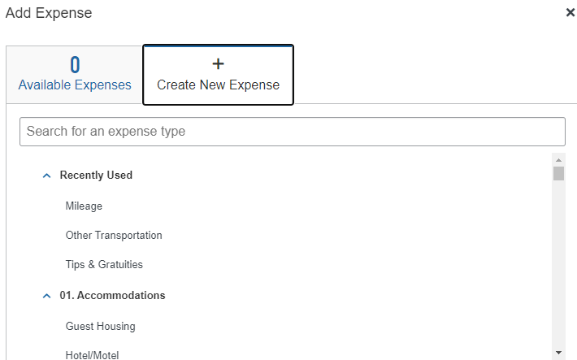
One tab will show any available expense you have added to ERS, either manually, using the App, or by emailing them. This will be covered in a more in-depth manner in the “Receipts” document.
The second tab is where you can create expenses from scratch.
Using the “Create New Expense” Tab
When you select the ‘Create New Expenses’ tab you will see a list of expenses to select from.
If no expense type corresponds with the receipt, use the ‘Miscellaneous’ expense type. It is asked that this be used sparingly. For more information on individual expense types please see the ‘Expense Types’ document.
To attach a receipt, click on the red ‘Upload Receipt Image’ box on the right. A window will open showing you the available receipts OR allowing you to upload one from your computer.
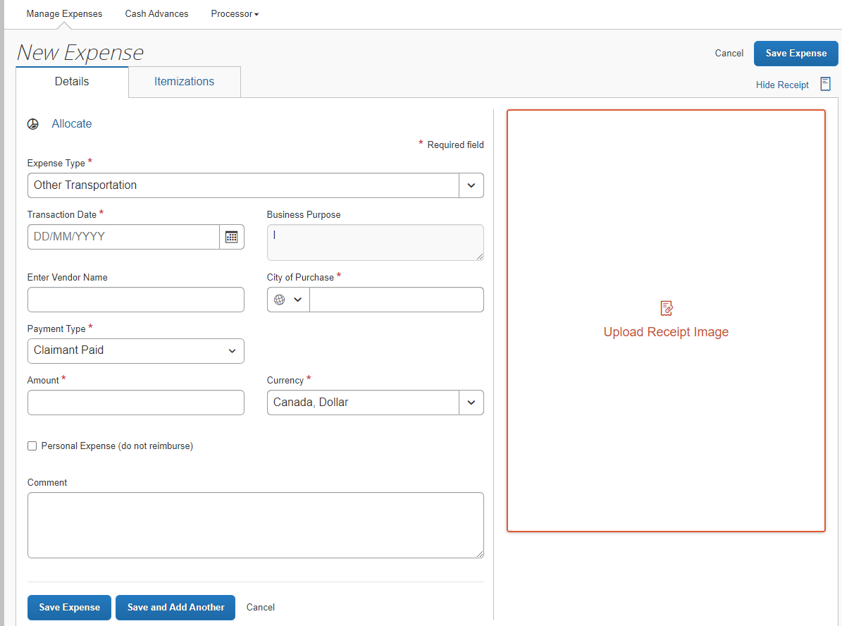

Available Receipts:
- If there are receipts available, you can select and assign the correct one to the expense line.
- Find the receipt you want to attach to the expense line and then select the ‘Assign’ button showing under the receipt image.
- You can also view available receipts by selecting the ‘View’ link under the receipt image. The full receipt will open, and you will be able to determine if it is the correct receipt.
  - If it is the correct receipt, select the blue ‘Attach’ button in the bottom right corner.
  - If it is not the correct receipt, select the ‘View All Receipts’ link in the top left corner.
Upload Receipts from Computer
- Search your computer for the correct receipt to assign to the expense line. Select the ‘Upload Receipt Image’ box marked in red.
- Follow the prompts on your computer to select and upload the receipt.
Once you have selected a receipt, you will be taken back to the expense page.
The receipt will be open on the right side of the screen. This is to aid in adding in the required information. You can hide the receipt by selecting the ‘Hide Receipt’ button above the receipt image on the right side.
NOTE: If the City of Purchase is not showing in ERS please enter the closest city, or capital of the country/province, and add an explanation. The City of Purchase must match the province or country for tax and currency conversion purposes.
Once you have entered the required information, select the blue ‘Save Expense’ or ‘Save and Add Another’ button.
The ‘Save Expense’ button will take you back to the overall claim. Selecting ‘Save and Add Another’ will open a new expense page allowing you to add another expense without going back to the overall claim.
- When you select ‘Save and Add Another’ the screen looks different than what you see when you create a new expense from the main claim page.
Using the ‘Expense Type’ drop down menu select the corresponding expense type for the receipt, and then complete the expense line in the manner described above.
NOTE: It may take a few seconds for the expense to save and add for you to be taken back to the over-all claim or the ‘New Expenses’ screen.

Using the ‘Available Expense’ Tab
If you have expenses listed under the ‘Available Expenses’ tab, you can select the expensed and then the ‘Add to Report’ button, located in the bottom right corner. The expense will be added to the claim. No further action from you will be required.
It is recommended that you open the claim and ensure that the information is correct.

Assigning a Cash Advance and Research Participant Advance to a Claim
If you have an outstanding Cash Advance to assign the claim it will have to be assigned after the claim has been created.

Please note that only one Cash Advance or Research Participant Advance can be attached to a claim.

Assigning a Cash Advance and a Research Participant Advance are slightly different.

To assign a Cash Advance:
- Create the claim.
- Go to the ‘Report Details’ drop-down menu.
- Select ‘Manage Requests’ under the Linked Add-Ons option.
  - You will only see active Cash Advance requests.

To assign a Research Participant Advance:
- Create the claim.
- Go to the ‘Report Details’ drop down menu.
- Select ‘Manage Cash Advance’ from the drop-down menu.
  - You will see both Cash Advance requests and Research Participant Advance requests.

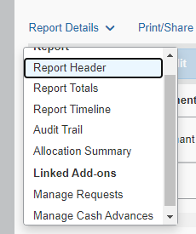
The ‘Requests’ page will open and will show ‘No Requests Added’.

Once you have selected the correct Cash Advance or Research Participant Advance to assign to the claim, the ‘Add to Report’ button will become active. Select it.

You will be taken back to the ‘Requests’ page, it will list the information regarding the advance. Ensure that it is the correct advance and then select the ‘Close’ button.

If this is not the correct advance, select the advance and the ‘Remove’ button will become active. Select it, this will remove the advance from the claim. You can then go back and add the correct advance.

Once the Cash Advance has been successfully added you will be taken back to the main claim page.

You will see a new box titled ‘Request’ with two columns:
- ‘Amount’ shows the total amount of the advance.
- ‘Remaining’ shows the amount that still has to be accounted for.

As you add expenses the ‘Remaining’ amount will decrease. The claim cannot be submitted until this amount is $0.00.

If you have added all related expenses and there is still a balance you will need to return the funds to Queen’s University. Please see the ‘Returning Funds’ section.

Returning Funds to Clear an Advance
If you have not accounted for the entire cash/research participant advance the balance will have to be returned to the University.
The funds can be returned in one of three ways:
- E-Transfer – to return the funds using E-Transfer please contact travel.advances@queensu.ca. You will be sent an email with instructions to follow. This is the preferred method.

- Cheque or Money Order – The cheque or money order must be made out to “Queen’s University – Kingston” and be attached to a completed “ERS – Cash Advance Return Receipt”. Theses can be sent via internal mail or Canada Post to the Financial Services office.

- Cash – Cash can be submitted with the “ERS – Cash Advance Return Receipt” to the Financial Services. DO NOT send cash through internal mail or Canada Post.
Once the funds have been returned the emailed receipt for the E-Transfer or the signed “ERS – Cash Advance Return Receipt” have been signed and returned to the claimant, it can be uploaded using the expense type 13. Cash Advance – Cash Advance Return.
Under the ‘Amount’ box enter the amount that was returned to the University.
This will clear the remaining amount of the advance and allow you to submit the claim.
Once the claim has been cleared it can be submitted in the normal manner.

Submitting a Claim
After you have entered and completed all the necessary/required expense you can submit your claim by selecting the orange ‘Submit Report’ button in the top right corner.
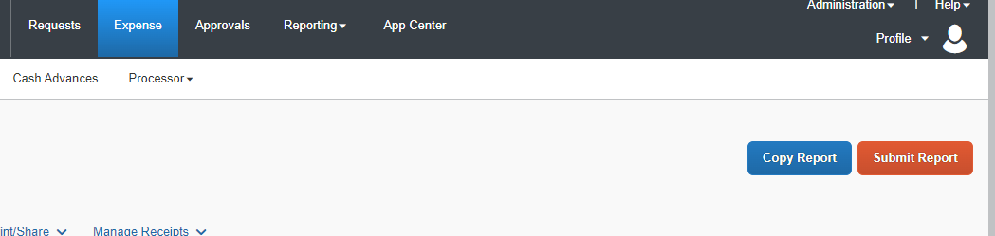
The ‘Copy Report’ option will be covered in a separate document.
When you select the ‘Submit Report’ button, the ‘User Electronic Agreement’ screen will open.
Please read the agreement and then, if you agree, select the ‘Accept and Continue’ button in the bottom right.
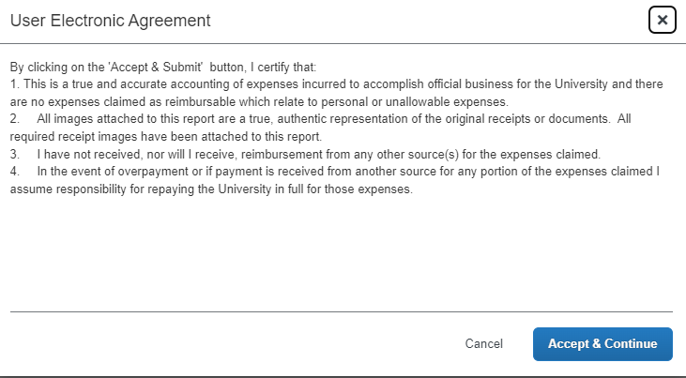
The next screen to open is the ‘Report Totals’.
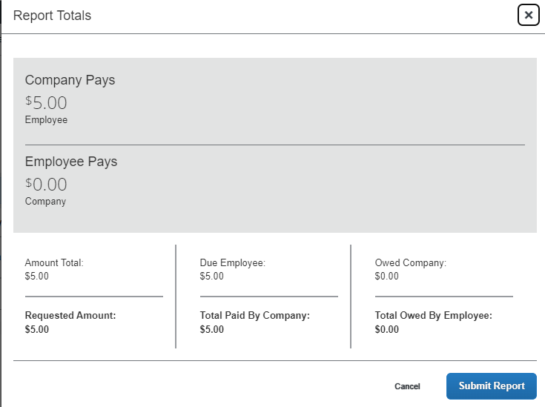
This screen will show you how much is to be paid to the company, Queen’s, and how much is owed to you, the claimant.
If you have assigned a Cash Advance with an outstanding balance you may also see ‘Amount Owed to the University’.
If there are any alerts on your claim they will be displayed across the top of the ‘Report Totals’ window. You can select the drop-down arrow and review them.
- The claim cannot be submitted until all alerts marked in red have been cleared.
After you have ensured that the information is correct select the ‘Submit Report’ button.
The ‘Edit Approval Flow’ screen will open. This is where you will search for your approver by LAST name.
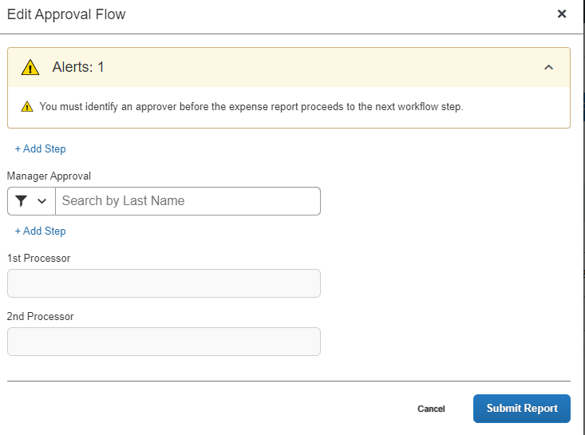
The 1st Processor or a 2nd Processor do not have to be added, your department may request this, but adding the 1st and 2nd processor can cause the claim to get caught in a cycle of approval.
- If the last name is hyphenated it is suggested, try the names together and then separately if the name cannot be found.
If you cannot find your approver in ERS please contact Anthony Bose, ajb19@queensu.ca.
Select the name of your approver from the list generated and then select the ‘Submit Report’ button in the bottom right corner.
When the claim is submitted you will see a small box at the bottom of the page. This is telling you that the claim was submitted successfully.
At the top of the screen, you will see the ‘Report Status’ window. This window will show you that the claim was submitted successfully and how much the claim was for.
When you click ‘Close’ you will be taken back to the main ‘Expense Tab’ and your claim will now be marked as ‘Submitted’.
The main ‘Expenses Tab’ is where you will be able to track the progress of your claim.
You will see three different status as the claim moves along the approval process:
- Submitted & Pending Approval: Waiting with your approver.
- Approved & In Accounting Review – Not Paid: Waiting for approval by Financial Services.
- Approved – Processing Payment: Approver and waiting for payment to be processed on Tuesday or Thursday.
Recalling a Claim
If you submitted a claim by accident or if you forgot to add an expense you can recall the claim.
To recall a claim, open the claim and then select the blue ‘Recall Report’ button in the top right corner of the screen.
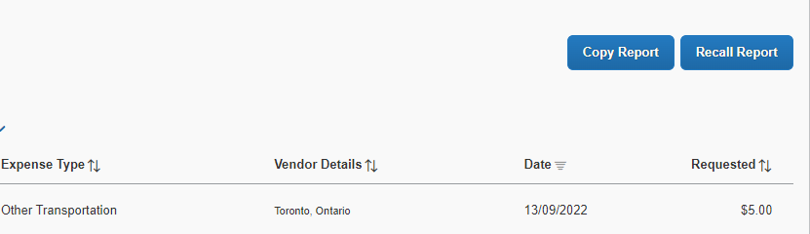
A window will open asking you to confirm that you want to recall this claim, select ‘Yes’.
The claim will now show as ‘Returned’ and the ‘Submit Report’ button will be active again. Once you have made your changes you can re-submit.
If final approval has been given, status shows as ‘Approved – Processing Payment’, please contact expenses@queensu.ca to see if the claim can be sent back to you for updates.

Printing a One-Page Summary
Printing a one-page summary, or saving as a PDF, is advisable so that it can be attached to the receipts until the claim has been processed and paid or saved as an electronic. Either version can be kept in file with your department to aid in the reconciling of accounts.
To print a one-page summary open the claim and then go to the ‘Print/Share’ drop-down menu.
From the menu select the report that you want to print. Your department may have a preference.
When you select a report, a new window will open showing you the report. Along the bottom your will see four options:
- Close
- Print
- Save as PDF
- Email
Select the options that best suits your needs and follow the prompts.

For more information or assistance using ERS please contact expenses@queensu.ca

