This document is to assist you in requesting a Pre-Approval for a Cash Advance.
A Pre-Approval request for a Cash Advance means NO funds will be issued to you. A Pre-Approval request means you are asking if it is okay to ask for the money, alternatively it is performing a mandatory budget check.
Pre-Approval requests are not required by Financial Services.
NOTES:
- If you will be using your personal or departmental Travel Card (T-Card) for the travel but are submitting a Pre-Approval request, please add a comment explaining this.
- If you are going to be using your departmental Purchasing Card (P-Card) or AcQuire, to purchase a large ticket item, but are submitting a Pre-Approval request for budget checking please add a note explaining this.
Remember that a Pre-Approval Request means NO funds will be processed or deposited into your account.
Requesting Pre-Approval
- Log into ERS using the following path, for more information on how to log into and use ERS please see the “ERS First Time Users Guide:
www.queensu.ca > Search and Sign IN > My Queen’sU – SOLUS, MyHR and more > Expense Reimbursement.
- Go to the ‘Request’ tab.
- Select the red ‘Create New Request’ box.
- Under the ‘Create New Request’ page, fill in all information marked with a red asterisk *.
  - If there is no Project code enter 000000.
  - In the comments box, please enter the total for Pre-Approval as well as a description of why you are requesting a Pre-Approval. Be as detailed as possible.
- Once all the information had been entered select the ‘Create Request’ button in the bottom right corner.

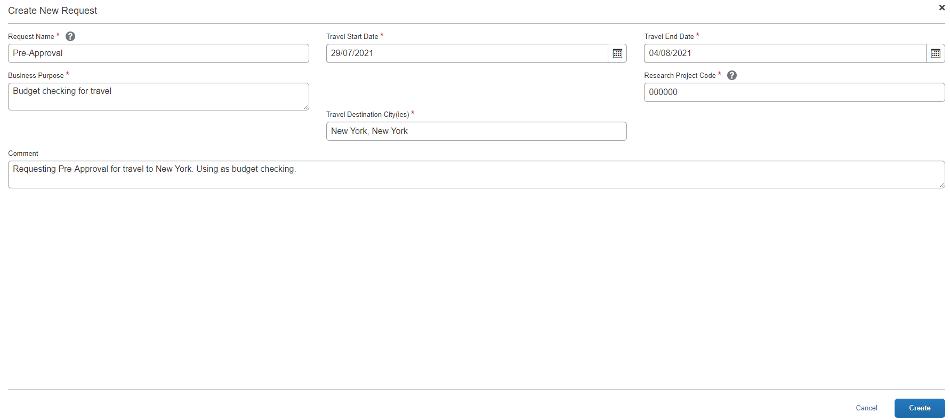

- You will be taken to the ‘Expected Expenses’ screen. Click add, from the drop-down menu select the expected expense that best matches what the pre-approval is for i.e., flights/hotels, Lab Supplies or if needed select ‘Miscellaneous’.
- Complete all fields marked with a red asterisk *.
  - In the ‘Transaction Amount’ field enter $0.00.
- In the comment section enter the amount that this expense is expected to cost and a description.
  - I.e., “Flights are expected to cost $1,500.00”

- Once you have entered all the information select ‘Save’. The expected expense will be saved, and you will then be taken back to the main request page.
- The expected expense will be listed and the ‘Estimated Total’ should be $0.00.
These amounts should be $0.00, this is conformation that no funds are being requested

- Before you submit you will have to add your approver by going to the ‘Request Details’ drop-down menu. From the list select the ‘Request Timeline’ option.
- The ‘Request Timeline’ window will open. On the left you will see a column titled ‘Approval Flow’ and a small blue ‘Edit’ button. Select it.

- The ‘Edit Approval Flow’ window will open. Search for your approver by LAST name.
  - If the last name is hyphenated you may have to try both names with and without the hyphen, or each name separately.
  - If you cannot find your approver contact Anthony Boese at ajb19@queensu.ca.
- Select you Approvers name from the list generated. This will activate the ‘Save’ button, select it and you will be taken back to the ‘Request Timeline’ screen.
- Under the ‘Approval Flow’ column your approvers name will now be listed.
Close the ‘Approval Flow’ screen using the blue ‘Close’ button in the bottom left corner.
- You will now be back on the main Request page.
- Select the orange ‘Submit Report’ button.
- Your request for Pre-Approval will be submitted.

Your approver will review the request for Pre-Approval and ensure that it meets requirements.
The request should be returned to you with a comment stating that this Request for Pre-Approval has been approved and a completed Cash Advance Request can be submitted, or the items can be purchased.
If the request is not returned or you are not contacted regarding approval, log into ERS to check the status of the Request. If it has been approved and sent to Financial Services for processing please email Kortney Fox, kf39@queensu.ca, to have the Pre-Approval request returned.

If you have any additional questions or concerns, please contact Kortney Fox at kf39@queensu.ca.

