New ERS Look – Quick Update - October 2023

SAP Concur has updated the ERS website look to a new brighter look, this has also changed where some applications are located. The basic function remains the same but Concur attempted to streamline the process and clean up the look of ERS.
New landing page of ERS
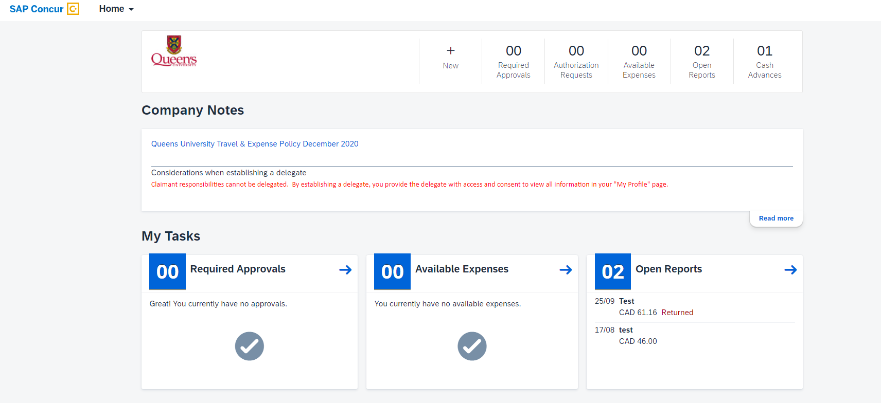

Accessing the Expenses Tab
There are two ways to access the expense tab to be able to submit claims:
Home Drop Down Menu
Click the Home drop down menu in the top left corner and then select the “Expenses” option.
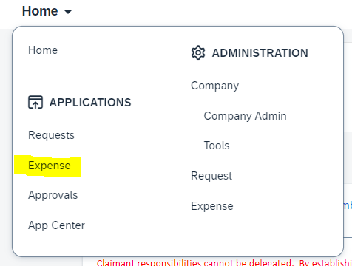

Available Expenses or Open Reports
There are several options along the top right of the screen, selection the “Available Expenses” or “Open Reports” will take you to the “Manage Expenses” page to create and submit claims.
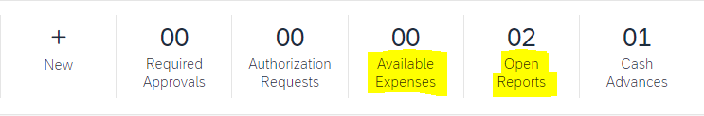
Any active claims will be displayed. If you wish to view previously submitted claims, select the “Active Reports” drop down menu and then select the appropriate date range.
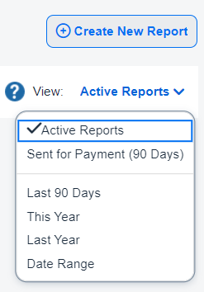
Creating a claim
The overall process of creating a claim remains the same. Select the “Create New Report” on the right side of the screen.
The “Create New Report” window will open. The main difference on this screen is that is it lighter in colour. The same information is needed.
Creating expenses has not changed, again the page is simply lighter in colour.

Subject Advance
The “Subject Advance” tab can be accessed from the “Manage Expense” page, by selecting the “Cash Advances” option.
Active requests will be displayed.
Past advances can be viewed by selecting the “Active Cash Advance” drop down menu and then select the appropriate option.
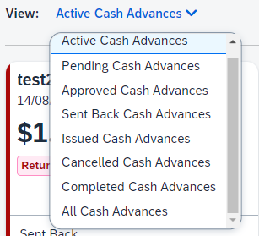
Access Requests Tab
The process to request Cash Advance is the same, however accessing the page has been updated and can be accessed one of two ways.
- Home drop down menu
Select the “Home” menu the select the “Requests” option.
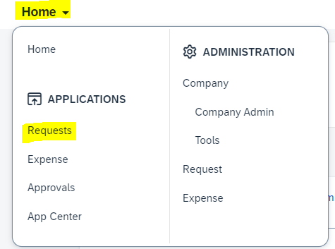

- Authorization Request link
Select the “Authorization Requests” link from the selection along the top of the screen.

Approving
Like the Request and Expenses tab the process of reviewing and approving has not changed, but the path to access the Approvals tab and the overall look has. The two options are:
- Home Drop Down Menu
Select the “Home” drop down menu in the top left corner, then select the “Approvals” link.
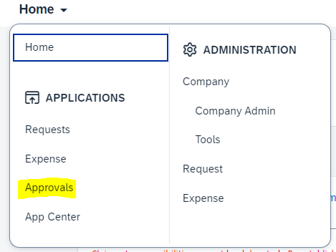
- Required Approvals Box
Select the “Required Approvals” box across the top.

Delegates
To act as a delegate, you will need to select the small circle in the top right corner of the screen, this is the Profile Settings button.
When you select the Profile button you will be given three options:
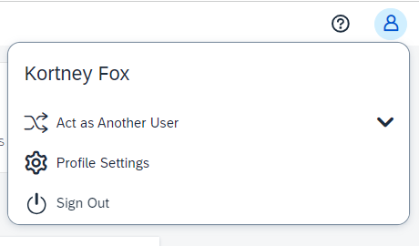

Select the “Act as Another User” drop down option.
The options are the same as is the process.
Select the “A Delegate for another user who has granted you this permission”, then search by the last name of the individual you want to act as a delegate for. This will activate the “Switch” button. Select it.
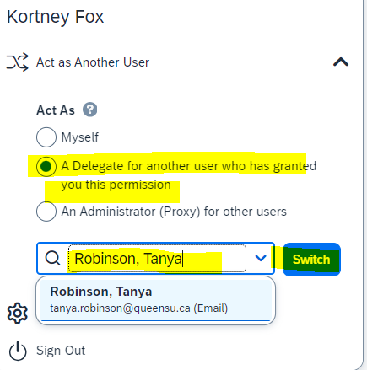
When you are acting as a delegate you will see a green box in the top right corner showing “Acting as Last Name, First Name”, use this to verify that you are working in the correct account.
To switch back to your account, click on the green bar, select “Myself” and then the “Switch” button. You will now be back in your own ERS account.

If you have any questions or concerns, please contact expenes@queensu.ca

