Accessing pinned reports in FAST
Log into FAST reporting
Once logged into FAST on the main page click on the pinned reports button on the left side of the screen
Click on “Group Pinned Reports” then “All Finance Users”
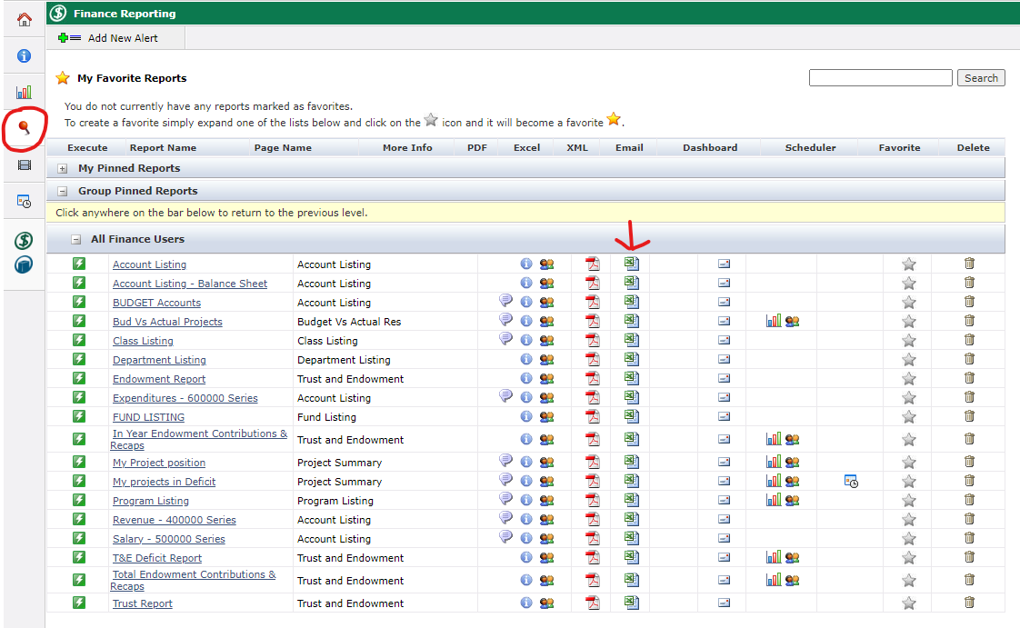
Click on the Excel icon next to the report that you wish to run. The Excel report will then come up in the downloads section of your browser to open.

