DEAL Model for Critical Reflection: Intro & Questions

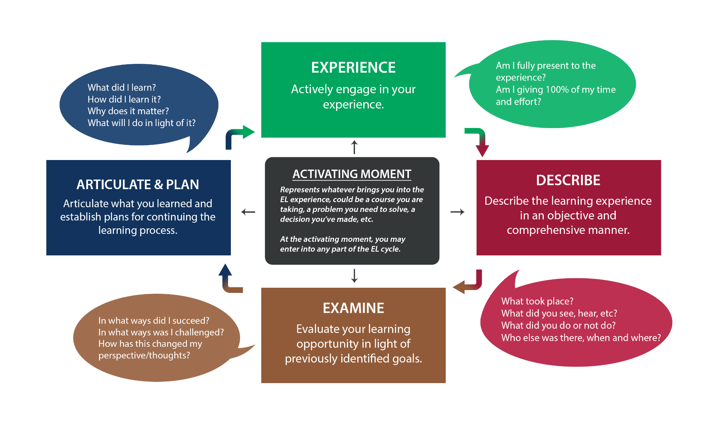
The DEAL model was developed by Dr. Sarah L. Ash of North Carolina State University and Dr. Patti H. Clayton of PHC Ventures/Indiana University-Purdue University Indianapolis. Their work on reflective practice in the context of applied and experiential learning has been widely adopted across North American post-secondary institutions as a guiding framework for critical reflection.

To begin…
Objectively DESCRIBE your experience by choosing 2 or 3 key experiences to focus the reflection on. Consider successes or challenges in relation to the learning goals you set out at the beginning of your experience.
- What were the most significant or reflection-worthy experiences?
- Where was I?
- Who else was there?
- When did this experience take place?
- What was said?
- What did I/others do?
- Why were we there?
Now we can EXAMINE those experiences through three different lenses.
Examine Experience from a Personal Perspective
- How did this experience make me feel (positively and/or negatively)?
  - How did I handle my emotional reactions?
  - Do I believe I should have felt differently than I did?
- What assumptions or expectations did I bring to the situation (including my assumptions about other persons involved) and how did they affect my actions?
  - To what extent did they prove true?
  - If they did not prove true, why was there a discrepancy?
- How have past experiences influenced the way I acted or responded to this situation?
  - Am I comfortable with the influence past experiences has on me?
- What personal strengths / weaknesses of mine did the situation reveal?
  - In what ways did they affect the situation, positively and negatively?
  - What might I do to build on strengths/ overcome weaknesses?
- Why did I, or did I not, have trouble working/interacting with other people?
  - What might I do differently next time to minimize such difficulties?
- What personal skills did I draw on in handling this situation?
  - What personal skills would I like to have had in order to have handled it better and how might I develop them?
- How did this situation reveal my own attitudes or biases, toward other people, toward the organization in question, etc.?
  - Do I need to make any changes?

Examine Experience from a Civic Perspective
- What was I / someone else trying to accomplish?
  - In taking the actions I / they did, was the focus on symptoms of problems or causes of problems? Was the focus (symptom or cause) appropriate to the situation?
  - How might I / they focus more on underlying causes in the future?
- What roles did each person / group / organization involved in the situation play and why?
  - What alternative roles could each have played?
- Did I / other individuals act unilaterally or collaboratively and why?
  - Should I / they have worked with others in a different way?
- Did I reinforce or challenge an assumption or social system by the way I acted?
  - How does this experience highlight the relationship between and larger systems?
- How else could I have handled the situation? Identify both the paths of least resistance and the paths of greater resistance.
  - Why did I / others follow the path I / they did?
- What agendas did I and others bring to the situation? Are these agendas appropriate?
  - Are they understandable?
  - Are they shared?
  - How are these agendas related to larger social or cultural issues?
- In what ways did power differentials emerge in this experience?
  - What are the sources of power in this situation and who benefits and is harmed?
  - In what ways might any dependencies be eliminated?
- What privilege did I/others bring to this situation?
  - What are the sources of such privilege? How am I, or others, disempowered by lack of privilege?
- How did leadership emerge in this situation, on my part and/or on the part of others?
  - What is in the interest of the common good in this situation?
  - In what ways is the individual good (mine or that of other people) linked to and/or contrary to the common good? What trade-offs between them are involved?
- In what way did any other trade-offs (long-term / short-term; justice / efficiency; etc.) emerge in this situation? Were the trade-offs made appropriate or inappropriate and why?
- What changes does this experience suggest are needed: within my group, within the organization, within our society more generally?
  - How can these changes be accomplished: with individual action or collective action / working within the system or challenging the system / etc.?
- How does this experience help me to better understand the organization’s vision, mission, and goals?
  - What does it reveal to me about the relationship between the organization and those it serves?
  - What does it suggest about how this relationship might be improved?

Examine Experience from an Academic Perspective
- What specific academic material is relevant to this experience?
  - Explain the concept, theory, etc. clearly and concisely so that someone unfamiliar with the material could understand it
- How did the material emerge in the experience? When did I see it or note its absence?
  - How did I or should I or someone else use it?
- What academic (e.g. disciplinary, intellectual, professional) skills did I use/should I have used?
  - In what ways did I/others think from the perspective of a particular discipline and with what results?
  - How was I able to apply a skill, perspective, or concept related to the academic material?
- How does this experience enhance my knowledge of a specific reading, theory, or concept?
  - Does it challenge or reinforce my prior understanding?
- In what specific ways are my understanding of the material or skill and the experience the same and in what specific ways are they different?
- What are the possible reasons for the difference(s) or inadequacies?
  - e.g. bias, assumptions, lack of information on my part or on the part of the author/instructor/community?
  - What questions should I ask to put myself in a better position to judge the adequacy of the material?
- Based on analysis of the experience in light of the course material, is the material (or my prior understanding of the material) adequate?

Finally, we want to work towards ARTICULATING what we’ve LEARNED.
“I learned that”…
- Express an important learning, not just a statement of fact
- Provide a clear and correct explanation of the concept(s) in question so that someone not in the experience could understand it.
- Explain your enhanced understanding of the concept(s), as a result of reflection on the experience
- Express in general terms, not just in the context of the experience (so that the learning can be applied more broadly to other experiences)
“I learned this when” ….
- Connect the learning to specific activities that gave rise to it, making clear what happened in the context of that experience so that someone who wasn’t there could understand it.
“This learning matters because” …
- Consider how the learning has value, both in terms of this situation and in broader terms, such as other organizations, communities, activities, issues, professional goals, courses, etc.
“In light of this learning” …
- Set specific and assessable goals; consider the benefits and challenges involved in fulfilling them
- Tie back clearly to the original learning statement.
Future directions…
- In what ways will I use this learning, what goals shall I set in accordance with what I have learned in order to improve myself and/or the quality of my learning and/or the quality of my future?

This document is adapted from Duke Trinity College of Arts and Science, Service Learning website, 2019: https://servicelearning.duke.edu/sites/servicelearning.duke.edu/files/file-attachments/deal-reflection-questions.original.pdf and PHC Ventures, Patti H. Clayton, 2013. https://curricularengagement.com

