DEPARTMENT OF ART
ART HISTORY & ART CONSERVATION

ARTH 402/807 3.0
Materials and Techniques in Early Netherlandish Painting, with a focus on Jheronimus Bosch

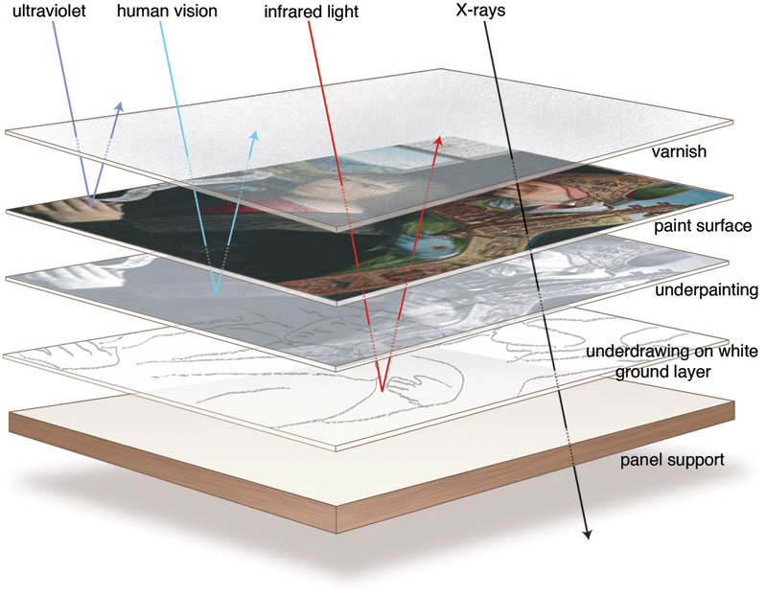

_________________________________________________________________________________

CALENDAR DESCRIPTION:
An in-depth study of Renaissance painting techniques in Italy and/or Northern Europe. Selected issues of technique and conservation will be examined within a broader art-historical framework.

Prerequisite: ARTH402: A GPA of 2.60 in 24.0 units in ARTH and Level 4 and registration in an ARTH Major or Medial Plan.

COURSE DESCRIPTION:
Early Netherlandish paintings, as material objects, are complex layered structures that were produced with a broad range of materials in distinct stages. Methods of technical examination, such as X-radiography and infrared reflectography, provide complementary information about these objects and their production. This course surveys how Netherlandish paintings were produced, and why this information can be of critical importance for art historians. Topics will include: the division of labour within a workshop, how to ‘read’ X-radiographs and infrared reflectograms, and how to interpret the results of dendrochronological analyses. The goal of the course is to provide the necessary toolset to critically read publications in the fast-emerging field of Technical Art History, with a special focus on the techniques applied by Hieronymus Bosch and his workshop. Although the painting examples used in this course will be limited to Netherlandish painting, many of these skills and concepts are applicable to other fields within the history of art.
Jheronimus Bosch remains an exceptionally popular painter and draughtsman. His death in 1516 was commemorated in 2016 with major exhibitions in ‘s-Hertogenbosch and in Madrid, which together drew well over one million visitors. The scholarly interest in the master from ‘s-Hertogenbosch typically focuses on the often-peculiar iconography of some of his works, which historians of art have tried to decipher since the late 19th century. This seminar will focus on the master’s materials and techniques. The student will thus participate in the discourse on historical painting techniques, modern methods of conservation and restoration, and art historical and scientific methods of research.
COURSE REQUIREMENTS:
A detailed list of readings and requirements for this lecture course will be sent by email to enrolled students before the first class. The course will be part lecture, part presentation, and part discussion. Attendance is mandatory. Evaluation will consist of two in-class presentations and written assignments, all on assigned topics. Please note: this course is not on onQ.

