DEPARTMENT OF ART HISTORY & ART CONSERVATION

Winter Term 2025

ARTH 800/900/3.0
Methods for an Expanded
Art History

INSTRUCTOR: Professor Allison Morehead
TIME: TBD
LOCATION: Ontario Hall 210
OFFICE: Ontario Hall 313
TELEPHONE: 613-533-6000 x 78804
EMAIL: morehead@queensu.ca
OFFICE HOURS: TBD
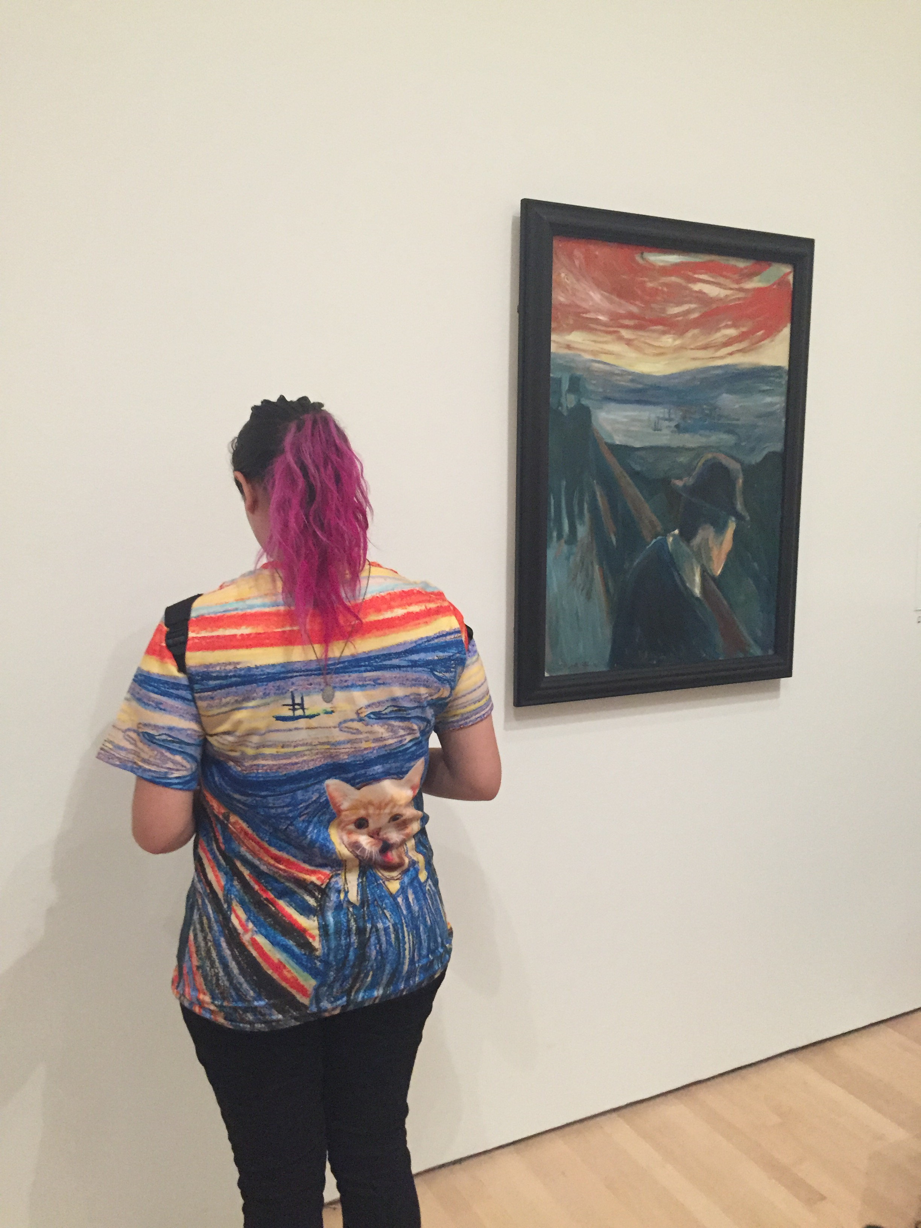

_________________________________________________________________________________

TEASER:
How do art historians put method and theory into practice? In this exploratory class, we read widely in iconography, formalism, biography, semiotics, post-structuralism, Marxism, social history of art, psychoanalysis, theories of gender and race, postcolonial and decolonial theory, seeking to experiment with the methods and theories most suited to the research questions that fuel our academic and creative interests.

COURSE DESCRIPTION:
In this course graduate students will explore various methods for an expanded art history concerned not only with things called art, but also with objects of visual and material culture, institutional practices of collecting and display, and the writing of art history. Class participants will read and experiment with applying iconography, formalism, biography, semiotics, post-structuralism, Marxism, social history of art, psychoanalysis, feminism, queer and trans theory, postcolonial and decolonial theory. They will improve their ability to read closely and critically and will test various ways to apply different methods and theories to art historical questions and objects. By the end of the course, students will have improved their ability to determine which methods and theories are most suited to the research questions and the things to which they are drawn. Assessments will be varied, and many will have applied components, encouraging students to experiment with different ways of putting method and theory into expanded art historical practice.
COURSE REQUIREMENTS & FORMAT:
A detailed list of readings and requirements will be available during the first class. Each class will be organized around seminar discussions, group work, and direct engagement with art, visual and material culture. Students will be responsible for presenting readings, art works, and their ideas to the class in structured and engaging ways, facilitated and modelled by the instructor. Regular and attentive attendance is mandatory.

