ARTH 308: Gothic Art: Romance, Power and Magnificence c. 1150-1450

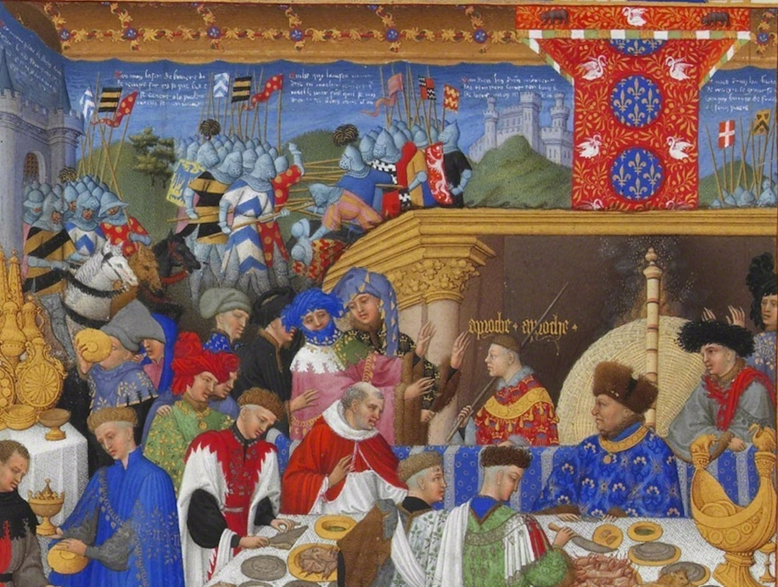

The period we now call “Gothic” was one of the most vibrant in the entire history of art. Covering all of Europe and the Mediterranean, parts of Africa, the Middle East, and Asia (via the Silk Roads), the Gothic might have been the first “international style” in art history. This course looks at the period anew through its art but also its literature. We explore not only the great buildings of the period (Prague Cathedral, Caernarfon Castle, Notre Dame in Paris, the Duomo in Siena), but also its proliferation of imagery in illuminated books (including the medieval bestseller—the Book of Hours), its monumental images and altarpieces, as well as its “luxury arts” including ivory carving from imported African ivory. We will consider some dominant themes of the Gothic, including employing our modern discourses of fashion and female glamour to the Virgin Mary, Chivalry, the crusade and “orientalism”, discussion of the apparent “modernism” of the Gothic, and its enduring relevance today in the 2019 fire of Notre Dame, Paris and the employment of new, digital technologies to study Gothic art.

