Queen’s University

Accessibility Annual Status Report

May 1, 2015 to April 30, 2016

This document is available in alternate formats, upon request. Please contact us at 613-533-2563 or by email at [equity@queensu.ca](mailto:equity@queensu.ca)

**Public Communication of the Accessibility Plans and Annual Reports**

Queen’s current and past Accessibility Plans and Annual Reports are available:

* Online at the Equity Office website at: [Reports and Plans](http://www.queensu.ca/equity/accessibility/accessibility-reports)
* On written request to the Equity Office, Queen’s University, Mackintosh-Corry Hall, Room B513, Kingston, ON, K7L 3N6
* By telephoning the Equity Office at (613)533-2563
* By email at [equity@queensu.ca](mailto:equity@queensu.ca)
* In alternate format as requested

**Accessibility Feedback**

Queen's recognizes that feedback is critical to the process of identifying and removing barriers to participation as well as improving how we deliver our services to persons with disabilities.  The [Accessibility Feedback Online Form](https://www.queensu.ca/forms/index.php/accessibility/add) can be used to submit feedback about accessibility to the Equity Office.

Feedback may also be given by emailing the Equity Office at [equity@queensu.ca](mailto:jeanette.parsons@queensu.ca), by telephone at (613) 533-2563, or by fax at (613) 533-2031. You may also send feedback via regular mail:

Equity Office  
Queen's University  
Mackintosh-Corry Hall, Room B511  
99 University Avenue  
Kingston, ON, K7L 3N6

QUEEN’S UNIVERSITY ACCESSIBILITY ANNUAL REPORT 2016

Section One: Introduction 4

Background 4

Vision & Commitment 4

Informed & Committed Leadership 4

Queen’s University’s Comprehensive Strategic Framework for Accessibility 4

Phase One 5

Phase Two (proposed) 6

Section Two: Status Update – Year 3 (2015/2016) – Meeting AODA Requirements 7

Information and Communication Standards 7

Design of Public Space and the Built Environment 8

Education, Training, & Awareness 9

Section Three: Status Update – Year 3 (2015/2016) – Exceeding AODA Requirements 11

Academic Accommodation Policy 11

Accessibility Café Series 11

Accessibility Hub 11

Accessibility Services Self-Study Report 12

Campus Mobility Project 12

Design of Public Space and the Built Environment 12

Diversity and Equity Self-Assessment and Planning (DEAP) Tool 12

Education, Training, & Awareness 13

Student Wellness Services 14

Mental Health 14

Steve Cutway Accessibility Award 15

Section Four: AODA Requirements for 2016 and Beyond 16

Information and Communications 16

Section Five: Conclusion 16

# Section One: Introduction

## Background

Under the Accessibility for Ontarians with Disabilities Act, 2005 (“AODA”) Queen’s University is considered a large designated public sector organization. As such, Queen’s is required to establish, implement, maintain and document a multi- year accessibility plan. That document constitutes Queen’s University’s Accessibility Plan (“[the Plan](http://www.queensu.ca/equity/accessibility/accessibility-reports)”) for the period May 1, 2013 to April 30, 2016.

AODA legislation also requires public sector organizations to prepare an Annual Report (“the Report”) relative to the multi-year accessibility plan. This Report documents the planning and implementation activities undertaken by Queen’s during the third year of the multi-year Plan; from May 1 2015 to April 30 2016.

## **Vision & Commitment**

Queen’s vision is to improve opportunities for persons with disabilities and to provide for their involvement in the strategic identification, removal, and prevention of barriers to their full participation. Accessibility planning provides the university with the opportunity to take a comprehensive look at its services, policies, procedures, practices and programs to determine which aspects of its operations require action towards advancing accessibility. In order to support progress and meaningful implementation of the Plan, a strong foundation built upon the following principles is necessary.

## Informed & Committed Leadership

* All Departments and Units are asked to provide input into the Plan.
* The Vice-Principals’ Operations Committee (VPOC) approves the Plan and receives annual status reports for information and comment.
* Accountability is demonstrated through the Plan and its related accessibility documentation which is made publicly available and in alternative formats upon request.
* Mandatory accessibility and human rights training is offered for all staff, faculty, and students acting on behalf of the university.
* Engaged and aware employees incorporate accessibility into daily practices at all levels of the organization and are encouraged to use an inclusionary lens when preparing policy and procedural documents or developing programs and services.

## Queen’s University’s Comprehensive Strategic Framework for Accessibility

Since its inception, the [Comprehensive Strategic Framework for Accessibility](http://www.queensu.ca/equity/sites/webpublish.queensu.ca.eqwww/files/files/accessibility/policy/Queens-University-Comprehensive-Strategic-Framework-For-Accessibility-Oct-2011.pdf) (“Accessibility Framework”) was conceived to be comprised of two phases:

1. **Phase One** - Compliance
2. **Phase Two** – Competency (proposed)

### Phase One

This phase enabled the development and implementation of an Accessibility Plan. Five Working Groups were formed comprised of members with direct responsibility and expertise as it pertains to accessibility requirements and identified priorities. Each Group also has a member that self-identifies as living with a disability and holds a particular interest in the Group’s area of focus. A list of the Working Groups is included below:

1. [Policy Advisory Working Group](http://www.queensu.ca/equity/accessibility/framework/policy-advisory)
2. [Information and Communications Working Group](http://www.queensu.ca/equity/accessibility/framework/information-and-communication)
3. [Employment Working Group](http://www.queensu.ca/equity/accessibility/framework/employment)
4. [Built Environment Working Group](http://www.queensu.ca/equity/accessibility/framework/built-environment)
5. [Education, Training, and Awareness Working Group](http://www.queensu.ca/equity/accessibility/framework/education-training-and-awareness)

The [Accessibility Coordination Team](http://www.queensu.ca/equity/accessibility/framework/coordination-team) oversees the implementation of the Accessibility Framework and is responsible for the development of comprehensive and integrated Accessibility Plans. This team is comprised of the Leads of the five Working Groups to support harmonized effort between each group.

The [Operational Review Committee](http://www.queensu.ca/provost/committees-and-reports/operational-review-committee) (ORC), a senior management committee reviews all accessibility initiatives at the request of the Vice-Principals’ Operations Committee, thus ensuring institutional-wide considerations are discussed. Ultimate approval of Accessibility Plans and initiatives rests with the Vice-Principals’ Operations Group (VPOC).

During the Fall of 2015, some Working Groups in the Accessibility Framework were placed on hiatus as their identified priorities achieved compliance of AODA requirements.

**Figure 1:** Phase One - Reporting Structure of the Framework for Accessibility

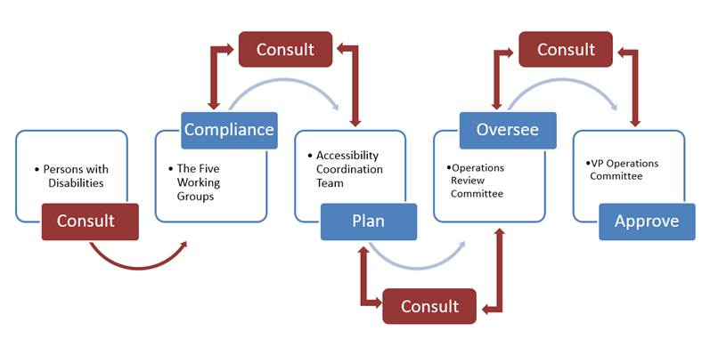

### Phase Two (proposed)

Through 2015, some original working groups were either placed on hiatus (because AODA obligations were met) or collapsed. The remaining working groups continued work towards compliance or competency of the university’s obligations under the AODA in the following manner:

1. Consult with Persons with Disabilities whose input in shared with the five working groups and throughout the cycle;
2. The process of each working group and committee are as follows:
   1. **Information and Communication Working Group**: continue to monitor Queen’s websites and departmental compliance efforts (with WCAG 2.0 Level A) every six months and make recommendations.
   2. **Built Environment Working Group:** continue its work to meet obligations of the Design of Public Space requirements coming into force in 2016.
   3. **Community of Practice** *(formerly the Education, Training, and Awareness Working Group has been put on hiatus)*: include input from the Centre for Teaching and Learning, ITServices, and the Equity Office.
   4. **The Policy Advisory Subcommittee (PSAC) of VPOC** *(formerly the Policy Advisory Working Group* *which has folded)*: has agreed to expand its Terms of Reference to include providing feedback on Accessibility policies, procedures, and guidelines and submit them directly to VPOC for approval.
   5. **Employment Working Group**: has been put on hiatus. The AODA requirements have been met operationally by the Human Resources department through the development of the [Accommodation of Disabilities in the Workplace Policy](http://www.queensu.ca/secretariat/policies/human-resources/accommodation-disabilities-workplace-policy), [Individualized Accommodation Procedures](http://www.queensu.ca/secretariat/policies/human-resources/accommodation-disabilities-workplace-policy/individualized-disability), [Disability Accommodation Guidelines](http://www.queensu.ca/secretariat/policies/human-resources/accommodation-disabilities-workplace-policy/disability-accommodation), [Return to Work Policy](http://www.queensu.ca/secretariat/policies/human-resources/return-work-policy), and [Return to Work Procedure](http://www.queensu.ca/secretariat/policies/human-resources/return-work-policy/return-work-procedure).
3. Any initiative from each active Working Group or Committee (with the exception of PSAC) is given to the Operational Review Committee (ORC) who provides feedback and endorsement ensuring institutional-wide considerations are discussed;
4. The VP Operations Committee, Principal or Vice Principal’s Group consults with ORC and provides final approval.

**Figure 2:** Phase Two – Proposed Reporting Structure of the Framework for Accessibility

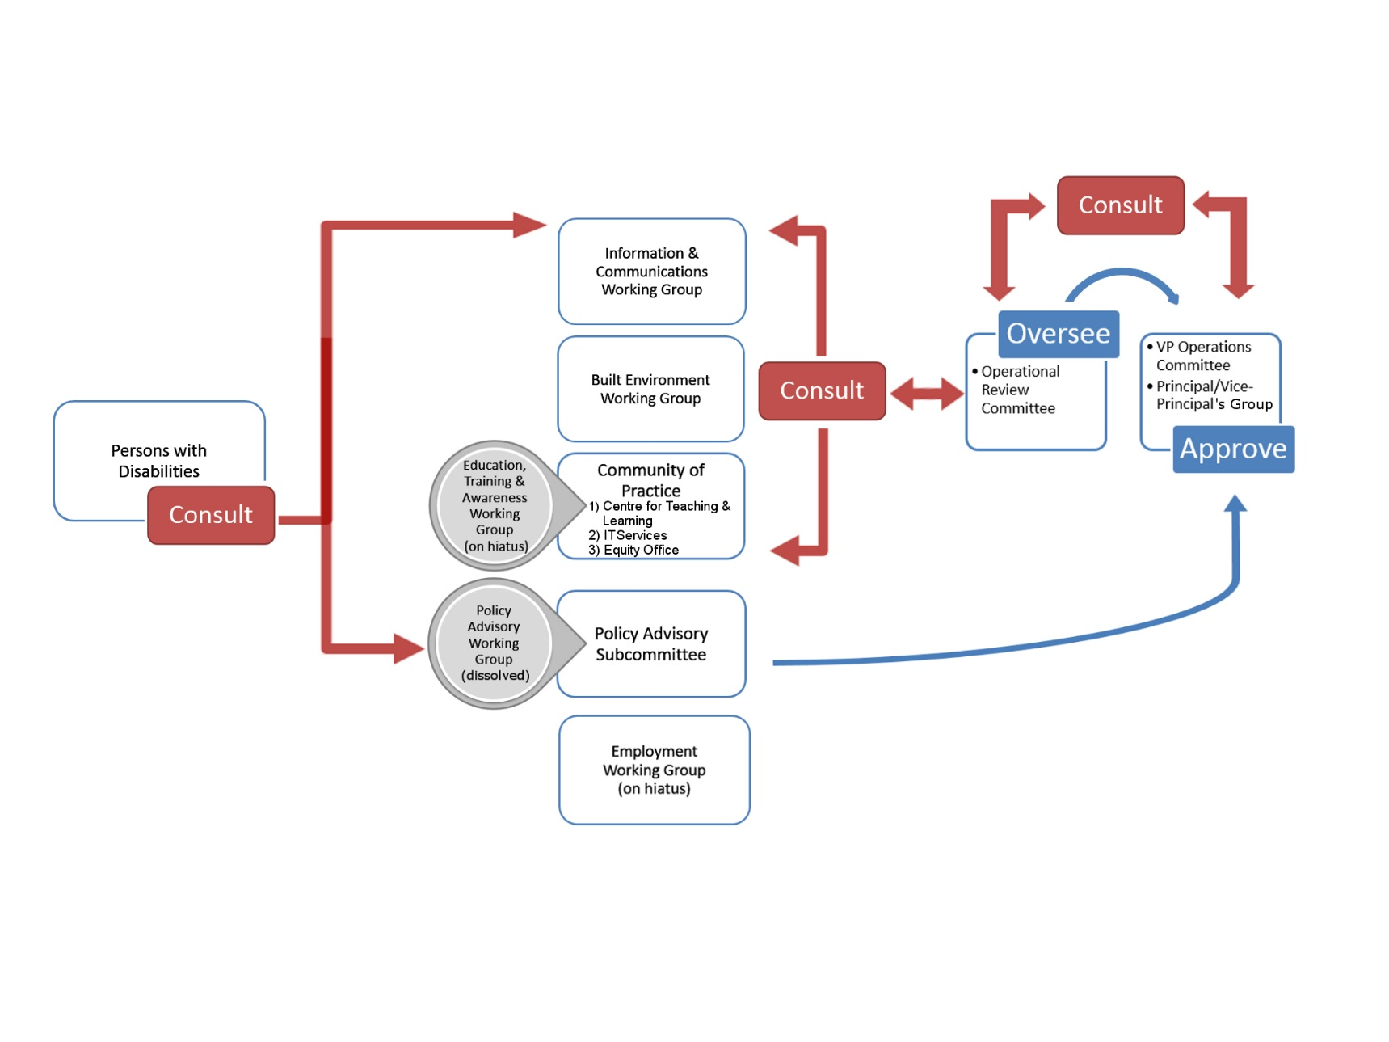

# Section Two: Status Update – Year 3 (2015/2016) – Meeting AODA Requirements

The following is a summary of actions taken to achieve compliance with 2015/2016 applicable requirements under the AODA and the Integrated Accessibility Standards Regulation (IASR 191/11). Compliance deadlines appear in brackets and refer to January 1st of the given year. Bullets in red indicate that although the compliance date has passed, there is a plan in place for reaching compliance.

## Information and Communication Standards

Communicating and providing information in ways that are accessible to all is another cornerstone of building an accessible organization.

**191/11, section 14 – Websites conform to Web Content Accessibility Guidelines – WCAG 2.0 Level A (2014)**

Although the compliance date has passed, work on a plan for compliance was undertaken in 2015.

* ITS has again purchased a one-year subscription to Site Improve.
* The Information and Communications Working Group determined what websites were inside or outside the scope of ISAR s.14.
* The Information and Communications Working Group created an inventory and gathered some basic data on all Queen’s websites from colleagues across campus so that its members could better understand Queen’s current rate of compliance.
* The University reported to the Accessibility Directorate of Ontario (ADO) that new internet websites and their content conform to the World Wide Web Consortium Web Content Accessibility Guidelines (WCAG) 2.0 Level A (IASR s. 14).
* The Information and Communications Working Group will continue to monitor Queen’s websites and departmental compliance efforts every six months and report back to the ORC.

**191/11, section 12– Accessible formats and communication supports (2015)**

* Upon request Queen’s will provide or arrange for the provision of accessible formats and communication supports for persons with disabilities in a timely manner and at a cost no greater than the regular cost charged to other persons.

**191/11, section 18– Libraries of educational and training institutions (2015)**

* Upon request Queen’s libraries will provide, procure, or acquire by other means an accessible or conversion ready format of print materials for a person with a disability.
* The Library formed the Section #18 Project Group. This Project Group is comprised of individuals representing many different units in the Library as well as the Accessibility Coordinator.
* The Group has completed much of its mandate including: an environmental scan of current transcription practices (converting course and print materials into an alternate, accessible format) in Ontario University and Colleges; recommending and changing Library Services for Students with Disabilities to the more inclusive, Library Accessibility Services; creating an online transcription request form, located on the Adaptive Technology Centre website, for students, staff and faculty wanting to request library materials in an alternate format;
* Queen’s Library recently received a new, sophisticated high-quality scanner that will improve the quality of scanned items.
* Ensuring that E-reserve materials are scanned for basic accessibility and will be transcribed into alternate formats upon request, if a student has a perceptual disability.

## Design of Public Space and the Built Environment

A 2-year Accessibility Audit of the University’s built environment has commenced February 2015 and Phase 2 of audits will occur in 2016. Approximately 6 million square feet of interior and exterior space in academic and administration buildings, libraries, student centres and any other buildings expected to undergo capital upgrades, updates or renovations will be audited.

* The Alma Mater Society (AMS) provided funds so that Campus Planning and Development could develop its own Queen’s Facility Accessibility Design Standards (QFADS). QFADS will ensure that new construction and renovation projects will meet or exceed AODA and Ontario Building Code (OBC) regulations.
* QFADS hopes to align with the new Maintenance Management System (MMS) used by Physical Plant Services and Residences to produce an accessibility checklist for construction projects.
* All single-user washrooms throughout campus have been re-purposed as gender neutral, and where appropriate, accessible. Appropriate signage has been affixed.
* An Equity Advisor participates on the Campus Planning Advisory Committee.

For new and significant construction or renovation projects, Queen’s University will:

* Newly constructed and redeveloped outdoor public use eating areas shall adhere to accessibility requirements.
* Newly constructed and redeveloped exterior paths of travel shall adhere to accessibility requirements.
* Newly constructed and redeveloped off-street parking facilities and on-street parking spaces shall adhere to accessibility requirements.
* New service counters (inclusive of replacing existing service counters) shall adhere to accessibility requirements.
* Fixed queuing guides shall adhere to accessibility requirements.
* Newly constructed or redeveloped waiting area where the seating is fixed to the floor shall adhere to accessibility requirements.
* Queen’s Accessibility Plan shall include procedures for preventative and emergency maintenance of accessible elements in public spaces and procedures for dealing with temporary disruptions when required accessible elements are not in working order.

**191/11, section 80.21-80.31 – Exterior Paths of Travel (2016)**

* At Duncan McArthur Hall, accessibility upgrades were identified in 2015. A $50,000 grant was awarded from the Service Canada Enabling Accessibility Fund and Queen’s matched the grant with an additional $50,000. Improvements to the exterior accessible ramp and accessible parking are slated to begin in May 2016. The improvements will include a new wider, concrete ramp with a gentler slope to be constructed from the parking lot to the main building. Secondly, existing accessible parking areas will be widened, repainted, and accessible parking meters will be installed.

## Education, Training, & Awareness

Queen’s recognizes the importance of collaboration in order to share and gain expertise. We continue to strengthen our capacity to inform, educate, raise awareness, and involve both persons with and without disabilities on and off campus. AODA training, both face-to-face and online, continues to be undertaken in 2015/16.

**191/11, section 7 & Section 16 – Training (2014)**

* Online training was provided on the requirements of the accessibility standards under Ontario Regulations 429/07 and 191/11 and on the Ontario Human Rights Code.
* The [Queen’s AODA Training Suite](http://www.queensu.ca/equity/training) can be found on the Equity Office website.
* Face to face training was made available upon request.
* The Equity Office tracked training completion and kept records for compliance purposes.
* Quarterly Compliance Progress Reports were sent to all departments and units.
* All employees and volunteers are encouraged and provided opportunities to access all available AODA training. However, for the purposes of tracking compliance of our employees, the Equity Office adheres to the Federal Contractors Program criteria: Employees are defined as those earning a salary and that are employed by the university for more than 12 weeks and/or work more than 14 hours per week. This excludes Adjunct 1’s, Affiliates, Associates, Co-op Students, Guests, and Casual employees.
* The tables below are a comparison of percentages of completion by active employees between May 2015 and May 2016.
* With an increase of more than 200 faculty and staff the percentage who completed the Customer Service Training remained almost the same.
* Although the Human Rights 101, Access Forward, and Accessibility Instruction for Educators training all saw completion rates increase, the table shows that more work is necessary for compliance.

| May 2015 |  |  |  |  |
| --- | --- | --- | --- | --- |
| Active Faculty and Staff (4282) | **Customer Service Training** | **Human Rights 101** | **Access Forward** | **Accessibility Instruction for Educators** |
| Total | 80.6% | 32.4% | 34.7% | 17.0% |

| May 2016 |  |  |  |  |
| --- | --- | --- | --- | --- |
| Active Faculty and Staff (4518) | **Customer Service Training** | **Human Rights 101** | **Access Forward** | **Accessibility Instruction for Educators** |
| Total | 80.8% | 41.8% | 43.3% | 28.3% |

# Section Three: Status Update – Year 3 (2015/2016) – Exceeding AODA Requirements

Queen’s strives to improve its ability to consult, engage, listen, and reframe accessibility issues so that the results work better to meet the expectations and needs of persons with disabilities. We continually seek new ways to engage with persons with disabilities concerning how Queen’s might best ensure everyone’s full participation. Below are some accessibility achievements that exceed AODA requirements.

## Academic Accommodation Policy

The university is building on its 1996 [policy concerning students with disabilities](http://www.queensu.ca/secretariat/policies/senate/queens-policy-concerning-students-disabilities) to detail the responsibilities of all areas of the university regarding academic accommodations for students with disabilities, as well as to reflect the Ontario Human Rights Commission's June 2014 policy document related to mental health disabilities. The updated policy and related procedures have been developed through the university’s Advisory Committee on Academic Accommodations.  The policy is expected to go to Senate early this fall.

## Accessibility Café Series

Accessibility Cafés are a chance for the Queen’s community to get together to discuss building an inclusive and accessible Queen’s community that follows the requirements of the AODA. Each Café has a unique topic and all participants are encouraged to share their perspectives and generate ideas around the question of: “how can we improve upon what Queen’s is doing already towards imagining and then building an even stronger inclusive and accessible Queen’s community?”

* This initiative was relaunched in January 2016;
* The first Café of 2016 was held on January 22 featuring keynote speaker David Lepofsky titled *“Ramping Up Stalled Action in Ontario on Disability Accessibility”*;
* The second Café was held on April 25 with titled *“Queen’s Facilities Accessibility Design Standards (QFADS)”*;
* The Equity Office has been conversing with ASUS and the AMS group Accessibility Queen’s (AQ) around forming a collaborative effort going forward to organize the Cafes.

## Accessibility Hub

* Since its launch, the Accessibility Hub has assisted **120** Queen’s Departments and Community Services with accessibility issues.
* Through the Accessibility Hub website, the Accessibility Coordinator has responded to:
  + Over **600** specific requests since the website launched (Oct. 2013).
  + Requests range from the simple to very complex. Including; built environment, video captioning, workplace accommodations, audio transcripts, website and document accessibility, physical access, accessible transportation, and accessible parking.
* Since Google Analytics was added to the Hub (Nov. 22, 2013) there have over **60,000 Visitors** to the website, viewing over **100,000 pages.**

## Accessibility Services Self-Study Report

In the Fall of 2014, a working group consisting of the Deputy Provost, the Vice-Provost & Dean of Student Affairs and the University Librarian conducted an accessibility services self-study. This working group provided recommendations for information and feedback to the Operations Review Committee and Vice-Principals’ Operation Committee.

In this reporting year the following recommendations of the Self-Study have been implemented.

* Establish the full-time position of the Accessibility Hub Coordinator, reporting to the Director of Human Rights and Equity Offices, and physically located at the Adaptive Technology Centre;
* Change the reporting structure of the Adaptive Technology Centre to a service under Library administration with a broadened mandate to support information accessibility for all individuals with disabilities at Queen’s;
* Queen’s Student Accessibility Services (formerly the Disability Services Office) to retain a student focus and continue to report to the Vice-Provost and Dean of Student Affairs.

## Campus Mobility Project

The goal of this project is to create a permanent, year-round **assistive mobility device rental service** on the Queen’s campus. This is in response to requests for Queen’s to provide wheelchairs and scooters to students, faculty, and staff who have a temporary disability. Funding for equipment has been identified with storage and service delivery to be finalized.

## Design of Public Space and the Built Environment

Queen’s is committed to greater accessibility into, out of, and around our facilities. In reporting Year 2, Queen’s already incorporated amendments to the Ontario Building Code concerning accessibility (2015) and the Design of Public Space requirements (2016) for its newly constructed or significantly renovated spaces, premises, and facilities.

* Campus Planning and Development has begun to create a Queen’s Facility Accessibility Design Standard (QFADS), adapting widely accepted FADS from select Ontario municipalities and universities, to the Queen’s experience.
* While provincial legislation outlines minimum building standards that public institutions must adhere to, Queen’s supports campus community members living with disabilities, and believes that a Queen’s FADS would guide the university to implement design and construction standards reflecting the needs of students, staff, and faculty, as well as Queen’s unique built environment. By informing and directing how the built environment at Queen’s will develop, a Queen’s FADS will shape the experience that students, staff, faculty, and visitors will have of Queen’s University for decades to come.

## Diversity and Equity Self-Assessment and Planning (DEAP) Tool

The DEAP Tool has been developed by the Queen's University Equity Office to assist Units to better understand the environments and climate relating to equity and diversity in their Units. Implementation of the DEAP Tool across units will be an additional method towards ensuring that the university not only meets, but in some cases, exceeds the AODA requirements.

The DEAP Tool is a self-audit tool for internal use for Units to:

* Understand the demographic profile of their staff, faculty, and students;
* Assess how inclusive the Unit is;
* Provide an opportunity to reflect on areas in need of improvement using the Diversity Score Card assessment template;
* Support further commitments to equity and diversity;
* Develop an action plan and timeline to enhance inclusion.

The Tool also is designed to complement other administrative responsibilities of units such as:

* Departmental Strategic Planning;
* Cyclical Review Process (CPR) and Queen's University Quality Assurance Process (QUQAP's);
* Hiring and Appointments Processes;
* Implementation of the Academic Plan.

## Education, Training, & Awareness

Queen’s recognizes the importance of collaboration in order to share and gain expertise. We continue to strengthen our capacity to inform, educate, raise awareness, and involve both persons with and without disabilities on and off campus.

* The ‘From Diversity to Inclusion in the Workplace’ Certificate Program co-developed between Human Resources and the Equity and Human Rights Offices continues to realize good enrollment rates.
* The Equity Advisor was invited to participate on the new AMS Student Life Centre Accessibility Committee.
* Throughout the year the Equity Advisor has been called upon on numerous occasions to provide accessibility advice to Departments and Units and also to representatives from AMS, ASUS, and SGPS.
* The Equity Advisor delivered a guest lecture to SURP 870.
* The Accessibility Coordinator co-presented at the University of Guelph Accessibility Conference in May 2015.
* The Accessibility Coordinator staffed information booths at SOAR and at the Graduate Students Resource Fair.
* The Accessibility Coordinator presented at the new Faculty Orientation and the Resource Fair for Dons and Residence Council.
* Both the Equity Advisor and the Accessibility Coordinator delivered accessibility training to Orientation leaders.
* Throughout the year, the Accessibility Coordinator has provided numerous training and workshops to numerous Departments and Units regarding website, document, and social media accessibility; including Alumni Relations, AMS, ASUS, School of Business, School of Medicine, CTL, ITS, and Department of English.
* The Accessibility Coordinator and the Equity Advisor where invited to present at the Disability and Sexuality Summit organized by Accessibility Queen’s.
* The Accessibility Coordinator delivered accessibility Training to Queen’s Residences and the Summer Student Web Resource Program (SSWRP).
* The Accessibility Coordinator provided awareness and was the institutional contact for the Council of Ontario Universities Annual Innovative Designs for Accessibility (IDeA) student competition.

## Student Wellness Services

Health, Counselling, and Disability Services (HCDS) was renamed the [S](http://www.queensu.ca/hcds/)[tudent Wellness Services](http://www.queensu.ca/studentwellness/) (SWS). It is the university’s central health care and related service provider comprising four streams of service:

* Health Promotion;
* Student Health Services;
* Counselling Services;
* Queen's Student Accessibility Services (formerly Disability Services Office).

SWS is committed to supporting the health and wellness of our students.

### Final Exam Accommodations

Queen’s Student Accessibility Services arranges final exam accommodations through the Exams Office. The number of accommodated exams provided by the Exams Office has increased through the years.

| Total Exam Accommodations | | | | | |
| --- | --- | --- | --- | --- | --- |
| Dec-2013 | **Apr-2014** | **Dec-2014** | **Apr-2015** | **Dec-2015** | **Apr-2016** |
| 2484 | 2388 | 2761 | 2542 | 3149 | 3196 |

### Mental Health

Student Affairs offers a number of programs designed to help students, faculty and staff support those experiencing mental health issues. These programs aim to:

* help provide timely, professional, compassionate care to students in distress;
* raise awareness about the personal and developmental impact of mental health problems;
* help reduce the stigma associated with mental illness;
* provide information and support to members of our community who are supporting individuals experiencing mental health challenges;
* encourage people to talk and help create more openness about mental health.

**Mental Health eHHHHhTraining**

* Identifying and Responding to Students in Distress (IRSD);
* Mental Health: Awareness, Anti-Stigma, Response;
* Mental Health First Aid (MHFA) Canada.

## Steve Cutway Accessibility Award

* Established in 2008, this award recognizes students, staff and faculty who demonstrate innovation, enthusiasm and compassion in creating learning and work environments that allow the full participation of persons with disabilities.
* The Equity Office coordinates the nominating group as well as the event.
* The 2014 Steve Cutway Accessibility Award was presented to James McNutt. James initiated the "[Video Accessibility Audit Project](https://www.youtube.com/watch?v=UyK3d0cKRgg)", in association with the Department of Campus Planning and Development, to demonstrate the challenges that face many persons with disabilities while navigating Queen’s University campus. In this video audit, James visited six buildings and toured common areas, accessible gender-neutral washrooms, and some classrooms. James believes that in order to facilitate an accessible campus, we benefit from the perspective of those who face accessibility challenges.

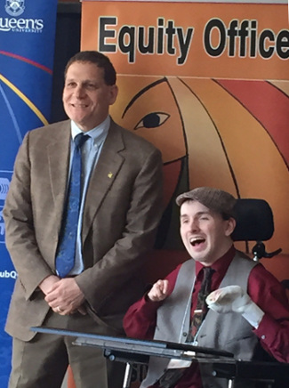

Principal Woolf and James McNutt

# Section Four: AODA Requirements for 2016 and Beyond

The following chart indicate future AODA requirements that Queen’s University’s will have to meet, including this reporting year. As for all other preceding AODA requirements, failure to meet these requirements could lead to a non-compliance designation and could result in financial implications for the University.

## Information and Communications

| **Timeline** | **Requirement** |
| --- | --- |
| January 1, 2020 | 1. Make available, upon request, accessible or conversion ready versions of printed material that are educational or training supplementary learning resources 2. Where available, our Libraries will be required to provide an accessible or conversion ready format of digital and multimedia resources or materials, upon request (some exceptions) |
| January 1, 2021 | 1. Ensure all internet website and web content will conform to established WWW Consortium Web Content Accessibility Guidelines 2.0 Level AA (some exceptions) |

# Section Five: Conclusion

Queen’s University has made great strides toward greater accessibility for our students, staff, faculty, and visitors. With the Integrated Accessibility Standards Regulation acting as a primary driving force, the Accessibility Framework has focused its efforts on achieving legislative compliance through the development and implementation of best practices approaches to accessibility in the post-secondary environment. As awareness of how accessibility contributes to student, staff, and faculty engagement expands, so too will the barrier-identification processes and responses that bring continuous improvement in accessibility for persons with disabilities. We are a community that works together to create an environment where everyone has a full and enriching Queen’s experience.